Ambar Vishnoi

TExas Hold’Em Poker

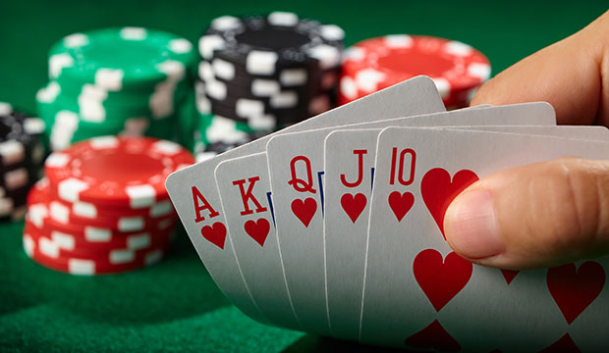

Contents

1.0 Analysis of the problem 2

1.0.1 Summary of the project 2

1.1 Problem Identification 2

1.1.1 Features that make the problem solvable by computational methods 2

1.1.2 Why the problem is amenable to a computational approach 3

1.2 Stakeholders 3

1.2.1 Identifying the end user 3

1.2.2 Why the solution is appropriate for the end user 3

1.3 Research 4

1.3.1 Similar problems and solutions 4

1.3.2 Essential features of the proposed solution 9

1.3.3 Limitations of the proposed solution 10

1.4 Specifying the proposed solution 11

1.4.1 Solution’s requirements 11

1.4.2 Success criteria 12

2.0 Design of the solution 15

2.1 Decomposition of the Problem 15

2.1.1 Breaking Down the problem 15

2.1.2 Justification 16

2.2 Describing the Solution 17

2.2.1 Explaining the Structure 17

2.2.2 Describing the Algorithms 25

2.2.4 Identifying key aspects 37

2.3 Approaching the Testing 38

2.3.1 The Test Strategy 38

2.3.2 The Test Data 41

# Analysis of the problem

### Summary of the project

Poker (Texas Hold’em Poker) is an extremely popular card game. Many casinos feature multiple tables and there are regular large tournaments played with professional players and large prize pools. The game is famous for several reasons: it is one of the few games where players will play and bet against each other, rather than playing against the casino (such as Blackjack). It is also famous because the game is not purely based on luck, nor is it solely based on skill, instead, in order to be good at the game, one must have a good ability to turn their luck (or lack of it) into results.

The game consists of 5 cards which all players ‘share’ (known as ‘community cards’), with each player having 2 cards to themselves (known as ‘hole cards’). The players will then bet against each other as the community cards get revealed, to see who has the best hand, which should be a total of 5 cards with at least one card from your hole cards.

However, I always have thought that learning the game proves extremely difficult, and what is even harder, is getting good at it.

My aim is to create a Texas Hold’em Poker game that will allow inexperienced players to develop their skills and learn the game, while also allowing experienced players to have a challenging opponent. I will do this by creating AI players at various difficulty levels so that stakeholders can choose the experience they desire. I will also be implementing a multiplayer feature that will allow stakeholders to play on multiple machines against each other. Furthermore, a key part of the program will be the Poker Tutor – a feature which can be turned on or off and will guide novice players into making the right decisions by displaying odds and giving tips. Lastly, a tutorial feature will teach the basics of the game to any new player.

## 1.1 Problem Identification

### 1.1.1 Features that make the problem solvable by computational methods

One key feature of the program is the Poker Tutor, which must calculate the probabilities of winning the hand at each turn and display them in a user-friendly way. The Tutor must also use these probabilities to display suggested moves and tips that match any scenario.

In order to achieve this, the program must use all the available data from the current hand and carry out multiple complex calculations. For future moves, the computer has to be almost 3 steps ahead of the player; therefore, the solution requires computational power since these methods and algorithms would be time consuming and labour intensive without the aid of a computer.

Furthermore, the fact that players are able to play on different machines, means that a computational method is required - there is a need to communicate between remote devices. Players are able to play in the same game yet not be in the same place geographically which would be impossible to achieve without using a computational method.

Additionally, tasks in my solution can be decomposed and abstracted. For instance, when looking at the Poker Tutor. This task can be broken into further subtasks: calculating probabilities, suggesting moves, giving appropriate tips; which can then be broken further. Furthermore, the subtasks that have been decomposed can be abstracted to ensure that they will work in any scenario not just a specific one, and so the problem requires computational thinking.

### 1.1.2 Why the problem is amenable to a computational approach

The game will require sequential processing, for instance, at the start of each hand, cards will be dealt, blinds will be placed, and then cards will be turned over in the centre. Iterative processing will also be required, during each betting stage players take turn deciding how much to bet, the process repeats itself until everyone has the same bet. Moreover, during the card dealing, cards will be given to each player repetitively, with each player receiving 2 cards from a randomised deck, alternating who the cards are dealt to. Because of the nature of these processes (require iteration and sequential processing), they lend themselves to a computational approach.

When dealing, cards will be animated from the deck into each players’ hands. Likewise, players betting and folding will need to be correctly displayed and animated. Furthermore, hole cards; chips; pot size and the community cards will all need to be stored throughout the game, appropriately. A need for animation, graphics and data storage makes the problem amenable to a computational approach since these would not be achievable without using a computer.

## 1.2 Stakeholders

### 1.2.1 Identifying the end user

The end-user can be any person who has an interest in poker, wants to learn poker, or who is already experienced at poker. The end user can also be an experienced gamer, a casual gamer, or a new gamer. End users who are new to poker should find that the solution is not too challenging, which might turn them away from the game. Whereas users who have more knowledge on poker should find that the solution is not too basic, to ensure that they do not get disinterested.

All end-users require the solution to be enjoyable, and the game should be relevant to their skill level. The solution should be simple to follow and efficient so that playing does not feel tedious, boring, or repetitive.

New gamers should be able to learn the controls and rules so that they feel comfortable while playing, on the other hand, experienced gamers should be able to bypass tutorial features so they do not get irritated while learning concepts they are already familiar with.

### 1.2.2 Why the solution is appropriate for the end user

The solution is able to satisfy end users of all levels of expertise in poker since there are various features that the end user can alter, so that the solution can be suited to them. For example, someone who is new to the game can learn the rules via the tutorial feature, whereas someone who is experienced is able to play against ‘expert’ level AI. There are also other options to make the solution easier or harder, such as choosing the amount of chips all players start with, or the blind sizes.

The end-user is able to play and compete against virtual AI which gives them the appropriate usage out of the solution since not all stakeholders will have other people to actively play against. Similarly, the solution provides end users with the ability to play poker even without the physical equipment required to play, such as the cards or betting chips. This appeals to the casual gamers, who might not want to invest in the physical equipment or want to spend time completing the tedious task of distributing chips and shuffling cards, but instead can play poker in an instant, using my solution. In addition, end-users can play against other end-users who are on different machines. This is important to the end users since they do not have to be physically together in order to play, instead can play at any place with other end users in separate locations.

The user interface will also be user-friendly and clear so that end users are able to get the most pleasurable and satisfying experience, which is a required specification of the end user. Additionally, stakeholders will be able to play the game with just a few clicks, making the solution efficient; this ensures that the end-user does not find the solution exhausting and laborious to play.

## 1.3 Research

### 1.3.1 Similar problems and solutions

#### 1.3.1.1 Solution 1 – Zynga Poker

Figure

Zynga Poker is one of the biggest free online poker games. Each account has their own set of virtual chips that they can use to enter tournaments, win jackpots, and challenge other players. The game boasts the fact that they offer both casual Texas Hold’em as well as competitive tournaments.

In Figure 1, a player has won with a flush, and pop up text has appeared on the display to show the user what hand has won. In addition the outline of the players profile has changed to indicate they have won. I would like to implement these features into my solution as this makes the solution more accessible to novice players since the display is clear and concise. Each player has their own profile picture, to make each player distinct from each other. This is a feature I would not like to implement since this is outside the scope of my solution, and it is much easier to give each player individual names, and unique pre-selected colours. Furthermore, the avatar on the left in Figure 1 is only included in the advertising, and is not actually included in the game-play.

The game offers a VIP program, a feature which I will not be implementing since it is not within the scope of the solution. The VIP program offers in-game benefits such as ‘exclusive chip package offerings and special poker game modes’. I will not be implementing this feature into my solution since I will only be creating one poker game mode – Texas Hold’em - and players will not have their own accounts with their own chip count. Instead, each game will be treated separately, and any winnings or losses will be kept local to each game. Also, ‘in-game benefits’ is a feature I do not want in my solution since I want to keep the solution fair for all stakeholders and not a ‘pay-to-win’ system.

Furthermore, a key feature of the game is variety – you can play a faster 5 player table or a slower but larger 9 player table. The user can also play competitive tournament style poker with ‘high stakes’ and can compete against millions of other players in large scale leagues. Or the user can opt to have a more casual ‘classic experience’. Zynga Poker also promises ‘games for all experiences and skill levels’[1].

An experience with a large variety will be a key feature of my solution – allowing stakeholders to fully customise their experience – for instance, choosing how many players they would like to play against, the level of AI, the amount of starting chips, the blind sizes, or the ability to play against real players. However, I will not be implementing tournament style games or large-scale leagues as this is outside the scope of my solution. The stakeholders require variety in my solution, to guarantee that the experience is relevant for their skill level and gaming experience.

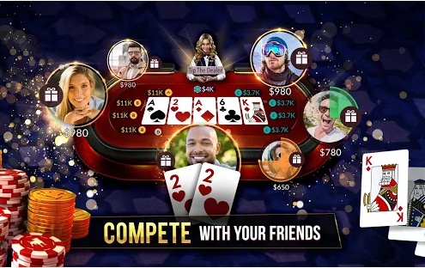Lastly, they offer fair play – the experience should feel like you are getting ‘the true Vegas-style game’. This is also a feature I would like to have in my solution as I feel that the user should have an experience as close to possible as a real table experience – so all probabilities and rules must be the same as in real life. Zynga Poker also runs adverts on their game, however, I will not be implementing adverts into my solution since this is outside the scope of my solution, and adverts are aggravating and bothersome to the stakeholders which makes the solution less appealing.

Figure

The actual table is shown in the Figure 2. On each players turn; a timer appears above the players’ profile. If the player does not make a move within this time, they are forced to fold or check depending on whether or not they have matched other players’ bets. This is a feature I would like to implement in my game to ensure the game goes smoothly and quickly. Moreover it makes it evident to the end-user how much time they have to make a move, and does not keep other players waiting too long, which 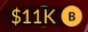guarantees that stakeholders do not lose their interest.

Figure

In addition, there are icons next to each player, signalling if the player has checked, called, raised, or folded, along with their bet amount. In Figure 3, an icon shows that a player has called (shown by the yellow ‘B’) $11K. These icons are an effective way to display a lot of information in a minimalist and straightforward way. Therefore, I will implement similar icons that will have the same purpose, in order to satisfy the stakeholders need for the solution to be as simple as possible. Novice players may find these icons difficult; however, a tutorial feature will explain these icons and their meanings, to certify that the solution is appropriate for all end-users.

#### 1.3.1.2 Solution 2 – WSOP Poker

Figure

In Figure 3, WSOP Poker’s main menu is shown. Although, I will not be including the assorted styles of tables as shown above, the overall aesthetic and layout of the menu is something I will be implementing into my main menu. This is because the menu is straightforward and obvious, so any new gamer will find it easy navigating around the menus. The menu includes large buttons such as ‘PLAY NOW!’ and the buttons are inside larger blocks which include imagery of the type of table the user will be playing. My menu will also feature blocks of imagery with large buttons for the various actions. WSOP Poker’s menu features a ‘Rules’ section whereas my menu will feature a tutorial section that will include all the basic rules of the game since I would like the solution to be accessible to players of all skill levels.

WSOP Poker’s table is shown in Figure 5. The table shares a lot of features with Zynga Poker’s table: the timers, the placement of hole cards, community cards, dealer, and bet icons. However, there are some distinctive features such as the ‘Fold’ and ‘All-In’ buttons which are located to the left and right if the user’s hole cards. These buttons are large and easy for the user to click and the large space between them creates a clear distinction between the two actions. For these reasons, the buttons in my solution will also have a wide separation and have a generous size, however, my solution should include all actions, for example, check, call or raise.

Another feature of this table is the gift feature – where users can gift any other player a certain amount of chips. This is a feature that I will not be implementing into my solution since this is not a requirement for the end user and is not realistic. The end user should have the most realistic experience while playing, so a gifting feature is not necessary as it does not fulfil this requirement.

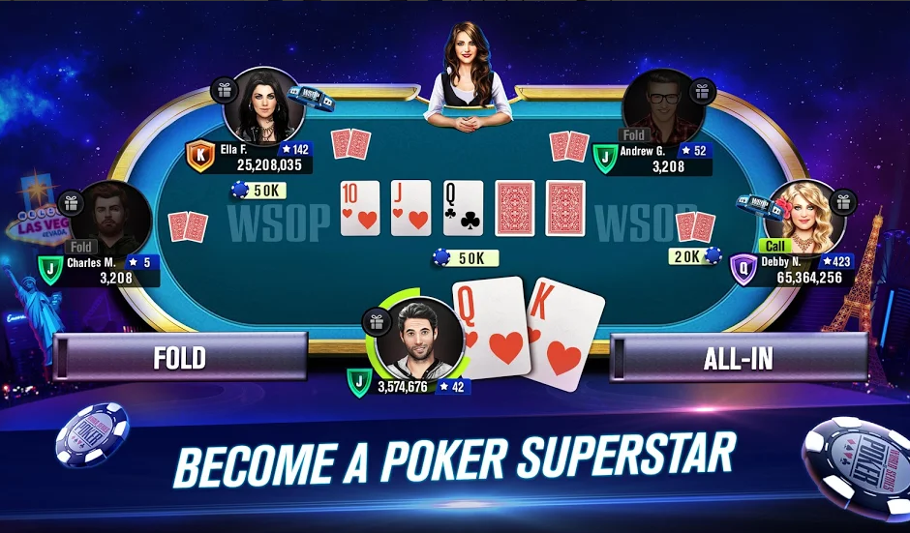WSOP Poker has a player ranking system, a competitive tournament style mode where players can ‘rise through the ranks’. In the Figure 5, players have an icon with a single letter next to their chip count – this is the player rank, a measure of how good a players’ poker skills are. Player ranks are outside the scope of my solution, so I will not be including them. Users will not have their own account and since each game is local (everything that happens within the game, stays within the game) ranks are a feature that would not fit with the overall solution.

In addition, when a player folds their profile picture becomes opaque to signal that that player is no longer playing this hand. This feature is useful and explicitly shows who is currently playing the current hand. Accordingly, I will be implementing this feature into my solution as this fulfils the stakeholders' requirements of having the game be easy to follow, however, since I am not implementing profile pictures, player names will become grey instead of profile pictures.

Figure

#### 1.3.1.3 Solution 3 – Poker heat

Figure

Poker Heat’s table is shown in Figure 5 and shares lots of similarities with the aforementioned solutions. Poker Heat also features a chat system which can be activated using the button in the top right corner. Although this does add some realism (allows users to speak with one another), it is not a necessity to the end user and therefore I will not be implementing it. It is likely that friends who will play my solution will be in the same geographical area and so do not need a chat system.

Poker Heat features buttons in the bottom right for the various actions even when it is not your turn. These are ‘pre-select moves’ – players can select a move before their turn, and when it eventually comes to their turn, the action is done instantaneously. This is a feature I would like to have in the overall solution, as it speeds up the tempo of the game and reduces the amount of work the user must do in order to play the game. This gives the user an overall better experience since they are not waiting around for their turn to come.

Figure

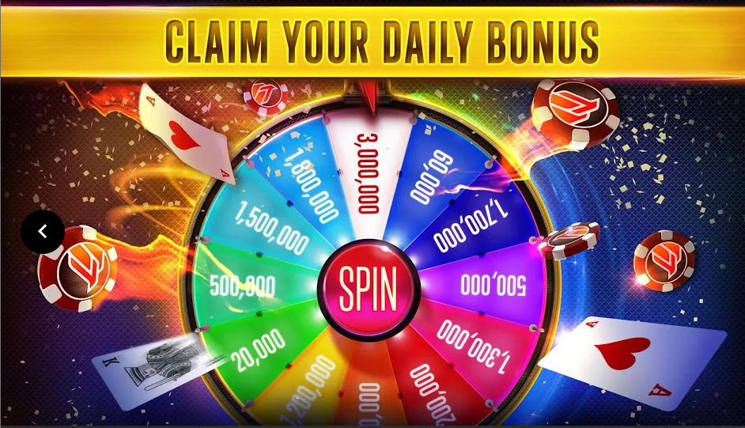Poker Heat has a bar next to the user’s profile, which provides a quick way for the user to see the likelihood of winning. Located next to this bar, is the user’s best possible hand. These features aid unpractised players in making better decisions, and therefore will be a part of the Poker Tutor. This means experienced player can play without these assists, and novice players can choose to have them on in order to have a more pleasurable experience. The bar is a much simpler way of providing the complex probabilities to a new player, however the tutor should have an option to enable the user to look at the probabilities in detail.

Figure

As shown in Figure 7, Poker Heat offers a collection of ‘rings’ which are rewards for playing the game. In order to earn these rings, the user must complete various missions and tasks given to them each day. Players can then choose to wear these rings on the table to show other players their achievements and poker skill. I have chosen not to implement a rewards system and daily missions since this is outside the scope of my solution.

Lastly, Poker Heat offers daily rewards and free chips that the player can use in their poker games by means of a daily free spin shown in the figure above. In my solution, the player does not have a chip count and each game they are given a fresh set of chips, therefore, the free chip system does not fit with my overall solution and so I have decided not to implement it. Furthermore, the chips you receive are scaled based on your ‘league’ and since I have decided also not to implement a ranking system, a daily rewards system does not suit my solution and is not a requirement for the stakeholders.

Lastly, common complaints about Poker Heat are that the odds are not realistic and there seems to be rigged hands[2]. My solution will ensure that all end users feel that the game is completely fair and that all probabilities are true-to-life and realistic. This makes the solution more appealing to stakeholders.

### 1.3.2 Essential features of the proposed solution

A key feature of the solution is the ability to customize the game experience: being able to activate the poker tutor, change AI difficulty, change number of players, starting chip amount and blind sizes. This variety of choices allows the end user to tailor the experience to each individual requirement that they might have – for example make the game more challenging or make the game shorter.

The solution should have an aesthetically pleasing menu that has all the appropriate actions such as create new game, settings, quit and tutorial. Each action should fulfil its purpose and be functional. The menu is the first thing the end user will see and so a good-looking menu will make the overall experience for the stakeholders better. A functional menu ensures the end user does not get frustrated trying to navigate the menu and fulfils the stakeholders’ requirement for my solution to be accessible and a satisfying experience.

The Poker Tutor should display probabilities in a novice friendly way, should suggest appropriate moves based on several variables: player chip amount, other players’ chip amounts, probability of winning, probabilities of getting each hand, and other players’ actions. The Poker Tutor should also give various tips throughout the game. The Poker Tutor is essential to providing a new gamer or a novice poker player a more pleasant encounter with my solution. Inexperienced players are able to learn Poker while also having the opportunity to win, which they might not be able to do, whilst learning poker against skilled opponents with no assists or tips.

Another essential feature of my program is the AI. Stakeholders require my solution to be played without other real players and AI are a perfect solution to this problem. Stakeholders can also customize the difficulty of the AI to suit their own skill level, which ensures that the solution provides the end user with a challenge whilst not being impossible to win.

Each player should have a fixed time limit per turn to ensure that the game goes quickly and there is not a lot of downtime between turns. A timer should be displayed for each player in an obvious way so that the end user knows exactly how much time they have to make a move. Furthermore, being able to pre-select moves is a key feature of the solution as this also minimises the amount of time between each turn where the user is doing nothing, and so therefore fulfils the stakeholder’s requirements of the solution being efficient.

Additionally, stakeholders require the ability to be able to play against other stakeholders. This allows for a more competitive style of poker while also creating a more realistic experience which the end user requires. It also allows stakeholders who may not have the physical requirements to play poker, to virtually play poker in a way that is as close to the physical experience as possible. Furthermore, stakeholders may want to play with less than the minimum number of players required to start a game, so the solution should allow the end user to fill empty spaces with AI of their chosen difficulty through a menu option, as this will make the table appear to be full.

The solution should make Poker easy and accessible to play while also making the end-user always feel occupied. Features such as small icons to signal each players’ move and large pre-select buttons and move select buttons will all fulfil these criteria. Moreover, player names will become opaque once they have folded and once a player has won, the solution should make it clear to end users, who has won; what they have won with (for example Flush or Straight) and the amount they have won. These features mean that novice gamers and inexperienced poker players will have minimal issues when playing my solution.

### 1.3.3 Limitations of the proposed solution

Each game is kept local to each other. This means that any amount of winnings or losses in a game will not be transferred over to the next game. Players also do not have individual accounts where they would be able to have their own chip amount. Because of these reasons, having features such as daily bonuses, free chips, missions, and tasks for the user to complete are all impossible in my solution. However, the Poker Tutor could offer tasks within each game that would help newer players to make better choices, and they could be rewarded within each game. On the other hand, receiving daily free chips, cannot be implemented since each player does not have their own wallet that carries over through each game, and rewards such as rings, that require multiple games to earn are also unable to be implemented.

In addition, the solution will only include one type of poker. This means that the solution has a reduced variety, since stakeholders might want to play a different variation of poker, however the solution only includes Texas Hold’em. Because of this, stakeholders will only have the option to customize their Texas Hold’em experience and not have to chance to experiment with other forms of Poker. The solution will only include one type of Poker since multiple variations is outside the scope of my solution.

Moreover, it is impossible to implement a league or ranking system because no information from previous games will be stored, so the solution will not have any idea on how skilled the end user is. Since the solution will not store any data on each player, a global leader-board is not possible, and so the solution will not be able to compare the skill level of players with other players and so would not be able to fit players into leagues or ranks. The solution could give a rough skill rating at the end of each game; however, this would not carry over to later games.

Furthermore, players are unable to interact with each other within my solution through features such as chatting systems or gifting systems. However, these features will not be a necessity to stakeholders as the majority of end users will be in the same location while playing my solution.

## 1.4 Specifying the proposed solution

### 1.4.1 Solution’s requirements

The solution will require basic hardware inputs: a mouse and a keyboard. This project will only be on PC, so these inputs are necessary in order to play the game since the solution requires the user’s inputs, which will be done by clicking buttons using the mouse, or entering in a username, or numbers (such as betting amount) using the keyboard. The solution will predominantly use the mouse however, most desktops already have these peripherals so I do not foresee any issues with the end-users.

Furthermore, the end user needs a monitor since the solution will display the poker game. In order to play Poker on my solution, the end user will have to see, the cards, bets, where to enter inputs and the menu screen, so the solution requires some type of display. A display is required to display the graphical user interface, which will aid novice users. Furthermore, the solution will be in 1920x1080 as this is the resolution most monitors will be in and is the largest and clearest display that the majority of stakeholders will have, however, the game should scale down if the display is not large enough.

The solution requires the operating system Windows 10, since this is the operating system, I will be developing my solution in and so will not work on other operating systems or previous versions. Windows 10 64-bit requires a 1 GHz processor, 2GB of RAM and 20GB Hard disk space, which are all basic specifications for most desktops, so end users should be able to meet them.

Moreover, Python 3.8.6 will be required as this is the version that I will be developing my solution in. Python requires a 64-bit CPU, with 4 GB RAM and 5 GB of secondary storage, so these are all additional requirements for the end users’ desktop since they will need Python. Furthermore the libraries that the solution will require are Tkinter, Time and Random.

Additionally, more secondary storage will be required for assets that my solution requires and for the solution itself, therefore the solution requires 25.05 GB secondary storage space in total, leaving 50 MB for assets and code. So the total requirements are a 64-bit 1 GHz CPU; 6 GB RAM; 25.05 GB secondary storage; a 1920x1080 display; a mouse and a keyboard.

### 1.4.2 Success criteria

|  |  |  |  |  |
| --- | --- | --- | --- | --- |
| **Number** | **Criteria** | **Justification** | **How will it be measured** | **Criteria met Y/N** |
| 1 | The solution must have a graphical user interface. | A GUI (Graphical User Interface) is more appealing to the end user than other types of user interfaces such as using command lines. Also a GUI will make the game easy to play for inexperienced users or novice gamers. | Check if there is a GUI or not. |  |
| 2 | The game should allow the player to fold at any time | The program should follow the same rules as real life Poker. | User testing and feedback from experienced gamers. |  |
| 3 | Players should be able to All-In at any point | The program should follow the same rules as real life Poker. | User testing and feedback from experienced gamers. |  |
| 4 | Players should only be allowed to play valid moves – invalid moves should be greyed out. | The program should follow the same rules as real-life Poker – for example, the player should not be able to check if they have not matched the pervious bets. | User testing and feedback from experienced gamers. |  |
| 5 | Blinds should be dealt automatically | Making these processes automatic means that the game feels smoother to the end user and means that they have to do less repetitive tasks so the solution does not feel tedious. | Play a game and check that the blinds are dealt at the start of each hand by the correct players. |  |
| 6 | The dealer button and blinds should rotate after each hand. | The program should follow the same rules as real life Poker. | Play a game and check that the blinds and dealer buttons are rotating as they would in real life. |  |
| 7 | If a player runs out of money they should be out of the game. | The program should follow the same rules as real life Poker. | Play a game and ensure that once a player runs out of money they go out of the game. This can also be checked through user testing and feedback. |  |
| 8 | If every other player has no money, then a winner should be declared and the game ended | The program should follow the same rules as real life Poker. | User testing and feedback. |  |
| 9 | The Poker Tutor should suggest helpful tips and moves. | Novice gamers should find that solution accommodates to their skill level. | User testing – novice gamers’ feedback |  |
| 10 | End users should be able to play against other end users. | End users may need to use my solution to play with others if they do not have the physical means to play poker. | Run the program on multiple machines. Check if they can connect to the same game. |  |
| 11 | End users should have the option to play against AI that matches their skill level. | End users require the solution to be appropriate to their own skill. Multiple AI difficulties fulfils this requirement. | User testing – feedback from players of various skill levels. |  |
| 12 | The menu and game must be aesthetically pleasing. | Experienced gamers will find that if the solution is aesthetically pleasing, they are more likely to keep playing. | User testing and feedback. |  |
| 13 | The Poker Tutor must display odds of winning the hand by using a percentage bar. | Novice gamers would appreciate the complex probabilities to be displayed in a simple and novice-friendly way | User testing and feedback. |  |
| 14 | End users should have the option to turn any assists on or off. | Experienced users will find that assists may take away from the realism and lower the skill required. | Play game multiple times, changing the assists each time. |  |
| 15 | All odds must be realistic and true-to-life. | End users require that the game should not feel fake, which may make the user irritated | Compare odds from real life to odds in the game by playing the game several times and collecting data. |  |
| 16 | Buttons should be large and unambiguous. | Inexperienced users may find it difficult understanding the game, so the solution should be clear to ensure that novice gamers have a pleasurable learning experience. | User testing and feedback. |  |
| 17 | The tutorial must introduce the solution to inexperienced users in a user-friendly way. | End users should be able to learn the controls, rules, and any helpful tips, in one place. | User testing and feedback from novice users. |  |
| 18 | End users should be able to play with different numbers of players or AI. | Customization and variety are key requirements for the end user as they allow the game to feel fresh and new whenever the end user plays. | Testing with AI and users on multiple machines with different starting conditions and variables. |  |
| 19 | End users must have the option to add AI to any multiplayer game | End users may not have enough people to play a multiplayer game, but still want a realistic experience. Options to fill multiplayer games with AI will therefore make the multiplayer feature accessible to more end users. | User testing and feedback. |  |
| 20 | Each player should have a fixed time limit on their turn. | Ensures that if a player goes AFK or simply wants to waste time, it does not ruin other player’s experience. | Whilst playing, do not play a move in your time, and check that the timer runs out. |  |
| 21 | Pre-select buttons should allow end users to select their move before their turn arrives. | End users should feel like they are always playing and not waiting around. Pre-select buttons ensure that the game feels smooth with minimal waiting time | Use pre-select buttons and check if they are functional and fulfil their intended purpose. |  |
| 22 | The end user should be able to dictate how much money they start each game with. | End users can choose how long they would like the game to be by choosing starting money, which is vital for end users who may have little time. | Start multiple games with different variables. Test if these changes fulfil their intended purpose. |  |
| 23 | Players’ names will become greyed out once they have folded. | This feature will make it explicitly clear to all players, who is in the current hand, and therefore is extremely useful for inexperienced players | While in a game, click the fold button and check if the name becomes grey. Check if this happens to other players. |  |
| 24 | If a player does not complete a move within their time, they should be forced a move | If the user runs out of time the program must move onto the next player in order to ensure a smooth experience. Therefore the player who has run out of time must be forced a move by the program. | Whilst playing, do not play a move in your time and see if the game plays a move for you. |  |
| 25 | The Poker Tutor should provide end users with the option to view the complex probabilities. | Slightly more experienced users may want to see more than just a probability bar. The poker tutor should allow these users to see the in-depth probabilities and odds | User testing and feedback. |  |
| 26 | End users should be able to skip the tutorial | Experienced gamers and players who have played the game previously, should not be forced to do a tutorial | While in the tutorial, click the skip button and check if the tutorial is skipped. |  |
| 27 | After each round there must be a winner and the pot must be given to the winner | The game should follow the same rules as poker in real life. | User testing and feedback. |  |
| 28 | End users should be able to save games and load into games that they have saved previously. | If a user does not have the necessary time to complete a game it is important they d not lose all progress as this would be frustrating for the end user. |  |  |

# Design of the solution

## 2.1 Decomposition of the Problem

### 2.1.1 Breaking Down the problem

Figure

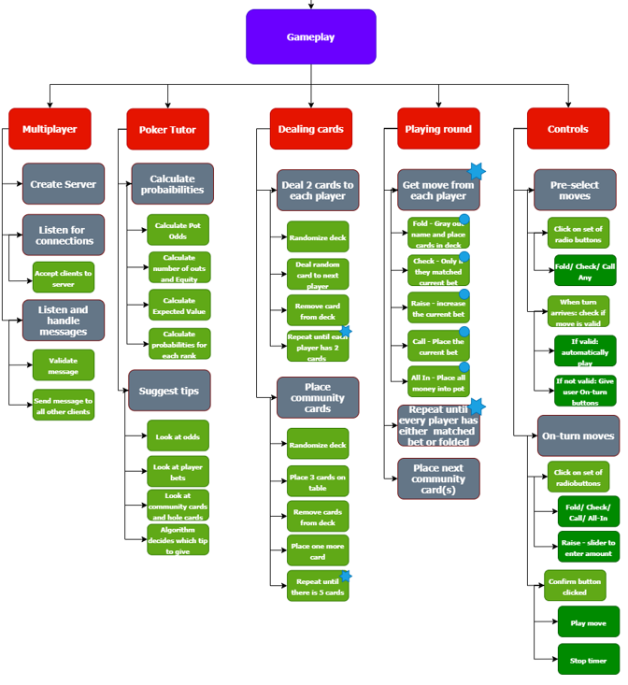

Figure

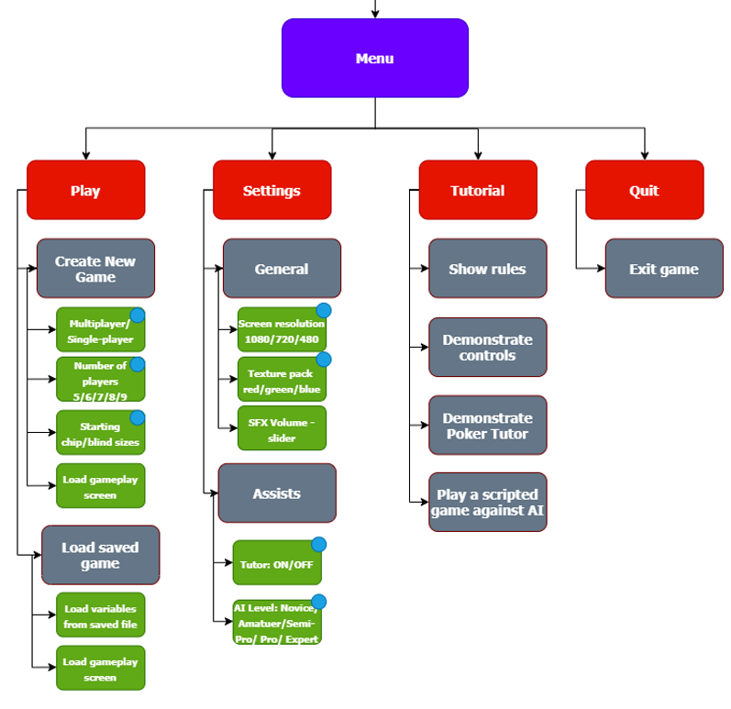

Figure

### 2.1.2 Justification

I decided to split the problem into two main parts which I based on the two main screens of the game: the game-play screen and the title screen. This is because these two screens can be treated separately and worked on individually, but once recombined; they make up the end solution.

The menu, shown in Figure 11, is decomposed further into different sections which are based on the menu options available on the title screen. Each individual section is independent of the other sections, so this was a clear area where the title screen could be easily decomposed. Furthermore, each section leads to a different menu screen, so breaking down the menu like this will make the process of designing these screens easier. The decomposition also shows that each individual screen belongs to the main menu or title screen, so will help when designing the files.

The first section is the ‘Play’ screen. This screen is split up into the two main actions that will be on this screen – Creating a new game and Loading a previous game. In order to create a new game, users must specify important constants that will dictate what type of game they would like to play – these options fulfil success criteria 10, 18 and 22 and so are a vital part of the play now screen. This action is necessary, since this is how stakeholders will be able to physically play the game. Moreover, stakeholders should be able to save games and continue them at a later stage – success criteria 28 – so the save game option is necessary.

The menu is broken into the settings section – users should be allowed to change key settings in order to create a more personalised experience. The settings are broken into two sections – general and assists. The general settings refer to any settings about the solution that does not affect the game – for example screen resolution. Whereas, assist settings refer to how much assistance the user wants when actually playing. Offering these settings to users is important that the solution should fit with each stakeholder’s individual requirements and stakeholders should be able to turn any assist off to meet with success criteria 14.

Lastly the menu is broken down into the final two sections – the tutorial and quit. Having a clear exit is an important usability feature, so including It in the decomposition will mean that the screen designing will be easier. The tutorial will demonstrate to novice gamers how all the controls work, explain the information given b the poker tutor, explain the rules of poker and finally allow the user to play a game to put all the skills learned to practice. The tutorial feature will take part on the gameplay screen which is broken down in a different section and is a key feature of the solution since it meets success criteria 17.

The gameplay screen is loaded when the user loads a game, creates a new game or plays the tutorial so helps to form a complete solution. Furthermore it is required by stakeholders to have a graphical user interface, so being able to play on an interface satisfies success criteria 1. This section is broken down systematically – each section represents a different part of the game that can be isolated and worked on individually. For example the dealing of the cards will be done separately to the playing of each round – at the end of the development stage they will be integrated to form a complete solution.

The first section that gameplay is decomposed to is the multiplayer aspect. I will be implementing a multiplayer feature into my solution as this not only increases the playability of the game but satisfies success criteria 10 and stakeholders’ requirements. I will be implementing this feature using the socket library.

The gameplay section is broken into the poker tutor section which is an important aspect since it is one of stakeholders’ key requirements and helps to solve the initial problem raised – improving novice players’ poker skills. Furthermore, it satisfies success criteria 13 and 25. The poker tutor is broken into each of the statistics the poker tutor should calculate, and its ability to suggest tips and moves which also meets success criteria 9.

Dealing cards is how the game will progress so was an obvious area to break down the problem. This process is broken down into dealing to each players hand and dealing to the community deck. These are the main types of dealing so was an obvious place to split up the problem. At the start of each round and stage cards will need to be dealt – so dealing is a prominent feature of poker and a key area of the gameplay which is why I broke down the problem further.

Moreover, the iterative process of each round is shown as a section since it is the key area of the game. The section is broken into the sequential process in each iteration – which is to get the move from the next player. This process is repeated for each player until all players are ready – then the next community card will be placed. I decided to break down this problem into the two different processes since the processes can be broken further and in the development stage it will be beneficial to see the processes clearly.

Furthermore, the controls will dictate how the user plays the game, so is an important section and is needed in the decomposition of the game play screen. The controls section is broken into the two types of buttons – the pre-select moves and the on turn-moves since these are all the controls the game will require. For pre select moves, the move must be validated and then played if it is valid in order to fulfil success criteria 21. For on turn moves the user is restricted on the actions they can complete based on the previous actions. All controls should be easy for the user to pick up and should be large and unambiguous to meet with success criteria 16.

## 2.2 Describing the Solution

### 2.2.1 Explaining the Structure

#### 2.2.1.1 Classes

I will be using Object Orientated Programming because the solution lends itself to a modular structure and so object orientated programming is the best choice. With object orientated programming I will be able to solve each problem easily, since I can solve one object at a time. Furthermore, modularity promotes easier debugging and troubleshooting, since each object is self-contained so errors are easy to locate. Testing will also be made easier since each class can be isolated and looked at individually.

In addition, inheritance will allow me to minimize the amount of repeated code – for example AI will have many commonalities with players but have small additional functionalities – object orientated programming allows me to inherit from the player class and so I will not have to reuse code. This will mean that time and effort will be saved in the development process.

Lastly object orientated programming is the most pragmatic and logical approach because of its modular style. It also promotes better programming productivity since systems can be easily upgraded which will be extremely useful in the iterative development of the solution – each iteration will be an upgrade of the previous. Additionally, OOP promotes cleaner code and it will also mean that I will be able to maintain greater control over the functions and methods since each class can be isolated and tested separately.

##### Player

|  |  |  |
| --- | --- | --- |
| **Attribute** | **Purpose** | **Data Type** |
| hand | Stores the players hand in the current round. | Array |
| name | Stores the players name | String |
| balance | Stores the players available chip count that the player can use. | Integer |
| position | Stores the player’s current potation on the table. Can be used to determine if a player needs to pay blinds or start action. | String |
| ready | Determines whether or not the player is ready to move onto the next hand (they have matched the current bet or have raised it) | Boolean |
| index | Stores the index of its self in the allPlayers array. | Integer |
| folded | Determines whether or not the player is still in this round – if they have folded they can no longer participate in the current round. | Boolean |

|  |  |  |
| --- | --- | --- |
| **Method** | **Purpose** | **Justification** |
| check() | Validates and then completes the check action once the player has decided to check. | Players should only be able to play valid moves – they should not be able to check after a raise – so this subroutine fulfils success criteria 4 |
| raise(amount) | Validates and then completes the raise action once the player has entered in the raise amount. | Players should only be able to play valid moves – they should not be able to raise to an amount less that 2x the previous bet– so this subroutine fulfils success criteria 4. Also, this subroutine fulfils success criteria 3 since players are able to go All-In. |
| call() | Validates and then completes the call action once the player has decided to check. | Players should be able to play any valid move that they would want to so this subroutine satisfies success criteria 4 |
| fold() | Folds the player so that they are no longer in this round. | Players should have the ability to fold at any time so fulfils success criteria 2 and 4 |
| bestRank() | Calculates the best possible hand that the player has with the current community cards. | A winner must be declared at the end of each round and so each players’ best rank will need to be calculated in order to satisfy success criteria 27 |
| force() | Once the player runs out of time, the subroutine will force a move based on what the current highest bet is | In order to keep the game running smoothly, players should be automatically made to playa moe if they run out of time which also fulfils success criteria 24 |

##### AI

The AI class will inherit from the Player class so will share all of its methods and attributes. The class will have additional methods and attributes to define the player as an AI.

|  |  |  |
| --- | --- | --- |
| **Attribute** | **Purpose** | **Data type** |
| difficulty | Dictates how hard the AI will be able to play against. A higher level AI will use more information and more complex algorithms to decide their moves. | Integer |

|  |  |  |
| --- | --- | --- |
| **Method** | **Purpose** | **Justification** |
| chooseMove() | Decides which action the AI will take on their turn. | The AI must be able to play like a real player and so should be able to choose its own move. Furthermore, AI of different difficulties should chose moves that are more appropriate to their level of difficulty in order to satisfy success criteria 11 |

##### Card

|  |  |  |
| --- | --- | --- |
| **Atrribute** | **Purpose** | **Data Type** |
| suit | Stores the suit of the card | String |
| value | Stores the number value of the card – King becomes 14 | Integer |
| image | Stores the physical image of the card | Image |
| name | Stores the filename of the image of the card. | String |

|  |  |  |
| --- | --- | --- |
| **Method** | **Purpose** | **Justification** |
| flip() | Changes the image to the opposing image. If the back of the card is displayed, the method will change it to the front and vice versa. | Players should not be able to see other players cards until the showdown – during the showdown opponents cards must be flipped in order to have the same rules as poker in real-life |

##### Deck

|  |  |  |
| --- | --- | --- |
| **Attribute** | **Purpose** | **Data Type** |
| cards | Stores all the card objects left in the deck that can be dealt. | Array |
| used | Stores all the cards that have already been dealt. These cards will go back into ‘cards’ at the start of each round | Array |

|  |  |  |
| --- | --- | --- |
| **Method** | **Purpose** | **Justification** |
| deal(location, amount) | Deals an amount of cards to the location. Takes in amount (number of cards to be dealt) and location (the array in which the cards should be dealt to) as parameters. | In order to match the true rules of poker, cards will have to be dealt to multiple locations every round. The cards should be randomly dealt in order to fulfil success criteria 15 |

##### Round

|  |  |  |
| --- | --- | --- |
| **Attribute** | **Purpose** | **Data Type** |
| community | Stores all the community cards. | Array |
| pot | Stores the current pot(s). The pot needs to be an array since there can be multiple pots if a player goes ‘All-In’ | Array |
| stage | Stores the current stage the round is at. | String |
| currBet | Stores the highest bet in the current stage. Players must either meet this bet or raise it by at least double. | Integer |
| currPlayer | Stores the index of the current player who is next to play their move in the allPlayers array. | Integer |
| bigBlind | Stores the big blind of the current round. | Integer |

|  |  |  |
| --- | --- | --- |
| **Method** | **Purpose** | **Justification** |
| nextStage() | Checks if everyone is ready to move onto the next stage (have the same bet or everyone has checked). If yes then reset currBet and currPlayer, deal the next card(s) and increment stage. | The subroutine is needed to progress the round. Also moving to the next stage when everyone is not ready to do so would be breaking the rules of poker. |
| calcWinner() | If the stage is at river and nextStage() is true then a winner must be calculate. Calculate each player’s best hand and compare with each other to find the winner. | Every round a winner must be decided so an algorithm is needed that finds the winner. Also the subroutine satisfies success criteria as a winner can now be paid out. |
| newRound() | Once the winner has been decided. A new round needs to be started. All attributes need to be reset including, pot, cards, community and each players’ hand. New cards must also be dealt to every player. | When the winner has been announced, a new round must be started and positions must be automatically rotated. Furthermore, blinds must be dealt automatically to satisfy success criteria . |
| nextPlayer( index) | Moves the action to the next player who has not folded. | In order to progress the stage the available player must be found and the action must be given to them in order to follow the rules of poker. |

##### Tutor

|  |  |  |
| --- | --- | --- |
| **Method** | **Purpose** | **Data Type** |
| level | Determines how much the tutor should display or calculate. Also increasing difficulty of AI will use higher levels of Tutor in order to determine their move. | Integer |

|  |  |  |
| --- | --- | --- |
| **Method** | **Purpose** | **Justification** |
| calcEV() | Calculates the expected profit the action will make over the longrun. | The poker tutor should suggest tips and show complex statistics and probabilities. Expected value is a statistic that can be used to suggest tips and so fulfils success criteria |
| calcEquity() | Calculates the percentage of improving the hand and therefore gives an approximate win percentage. | Equity is needed as the poker tutor is required to show the user a percentage bar that shows how strong the user’s current hand is. It is also needed to calculate other statistics. |
| calcEachRank() | Calculates the percentage that the player will end up with each rank. | The probabilities of achieving each rank are needed in order for the poker tutor to give tips. Users should be allowed to see the complex probabilities to satisfy success criteria . Therefore the subroutine calcEachRank is required to form a complete solution. |
| calcOuts() | Calculates the number of cards that make up the specified rank. | The number of outs are required by other crucial subroutines such as calcEquity and calcEachRank. Therefore calcOuts is required by the solution in order to complete these subroutines and the poker tutor object. |
| suggestTip() | Gives the user a hint on what to do. | The poker tutor should be able to suggest tips to fulfil success criteria . Furthermore, tips should help novice gamers to improve at poker, which helps to solve the original problem. |

#### 2.2.1.2 UI DESIGN

##### Title screen

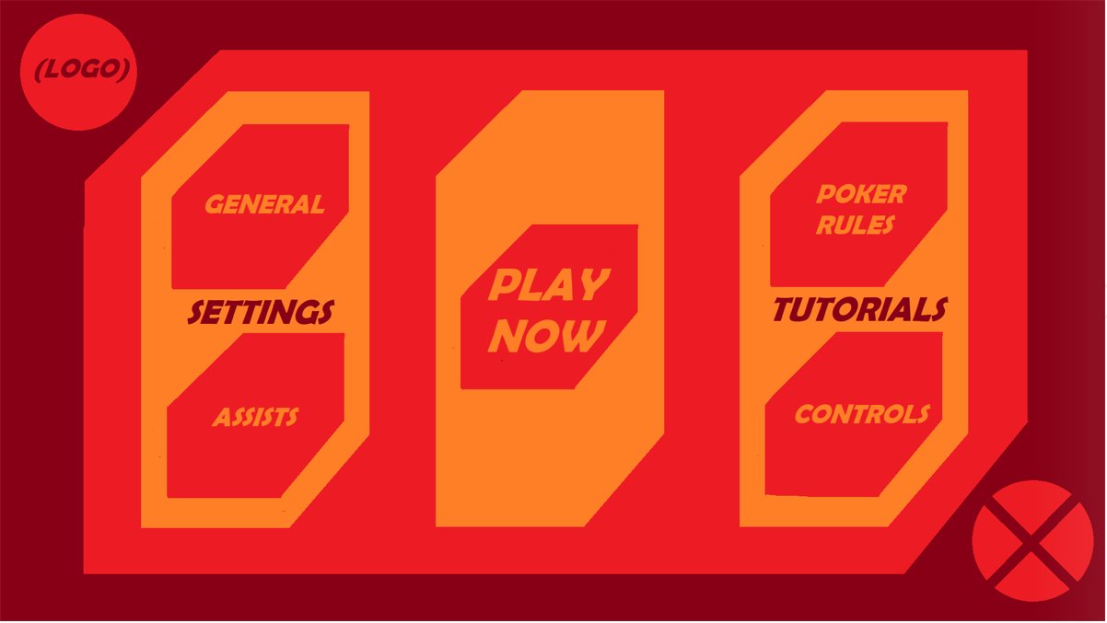In Figure ,the first iteration of the title screen is shown, the use of a GUI satisfies success criteria 1. All buttons are ordered in larger hexagonal blocks in order to make navigating the menu straightforward and simple, which fulfils success criteria 16. The “PLAY NOW” button is bigger than all other buttons and is centred in the screen to make it stand out to other buttons. The rest of the buttons are split into their respective sections which are titled in order to aid inexperienced gamers with navigation.

Figure

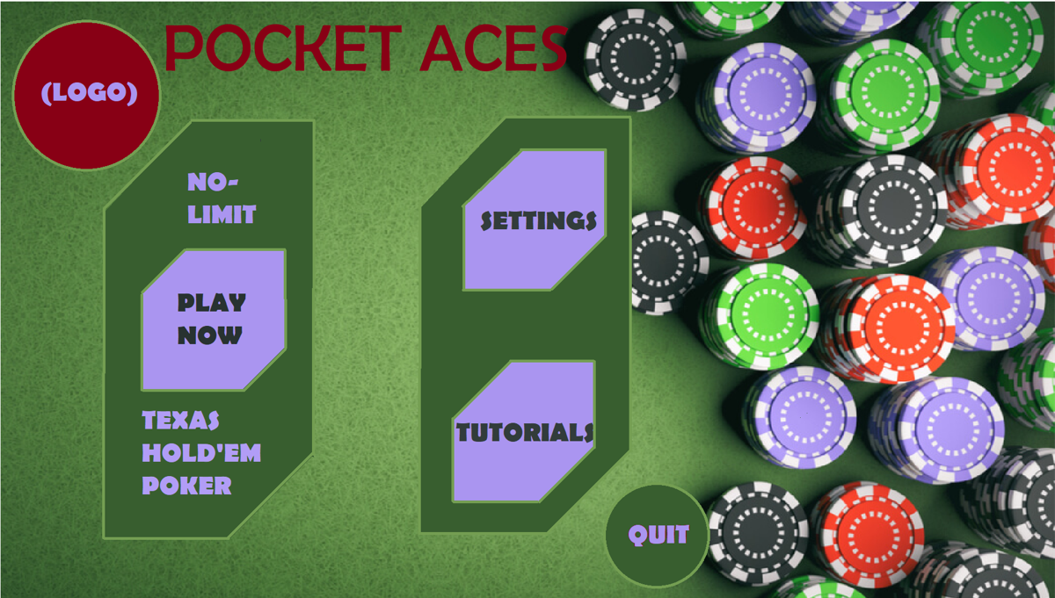After user feedback, I decided to make another iteration. Users suggested that I make a change to the colour scheme and add more imagery – there was nothing on the screen that represented the game that was being played, apart from the word “poker” written once on a button. The colours were too vibrant and were not aesthetically pleasing; instead a calmer colour scheme would be more suited. Moreover the lack of imagery further emphasised the fact that the screen did not represent poker and so would not be suitable for inexperienced users. Furthermore the quit button is ambiguous to new gamers – it is much clearer to have the words quit instead of a red X symbol that could confuse novice gamers.

Figure

In Figure , the second iteration is shown. The screen has a background image of poker chips which is a significant improvement to the first iteration since the screen clearly signifies a gambling game. In addition, including the title of the game “Pocket Aces” and the label “Texas Hold’em Poker” next to the play button, make it explicitly clear that the game that the user is playing is poker.

The quit symbol has been replaced with the word “QUIT” to make it clear for inexperienced users, and the colour scheme has been changed to reflect the background image. Also the number of buttons has been reduced for simplicity for the end user and will also make it easier to implement since each button will lead to individual screen.

Users complimented the choice of background image and title – commenting on how the screen made it much clearer that the game was about poker and how combining two sets of buttons into one set made navigation significantly easier. Feedback also suggested that the change of quit button was beneficial and that explicitly putting “Texas Hold’em” eliminated any chance of confusion about which type of poker that users would be able to play. However feedback also suggested that the colour scheme was unappealing and the colours of the buttons and blocks did not match with each other or with the background image. Users appreciated the font choice but did not like the different text colours, commenting on how the text did not stand out against the colours they were on, so did not satisfy success criteria 12. Therefore, I decided upon user feedback that another iteration would be needed that satisfied all appropriate success criteria.

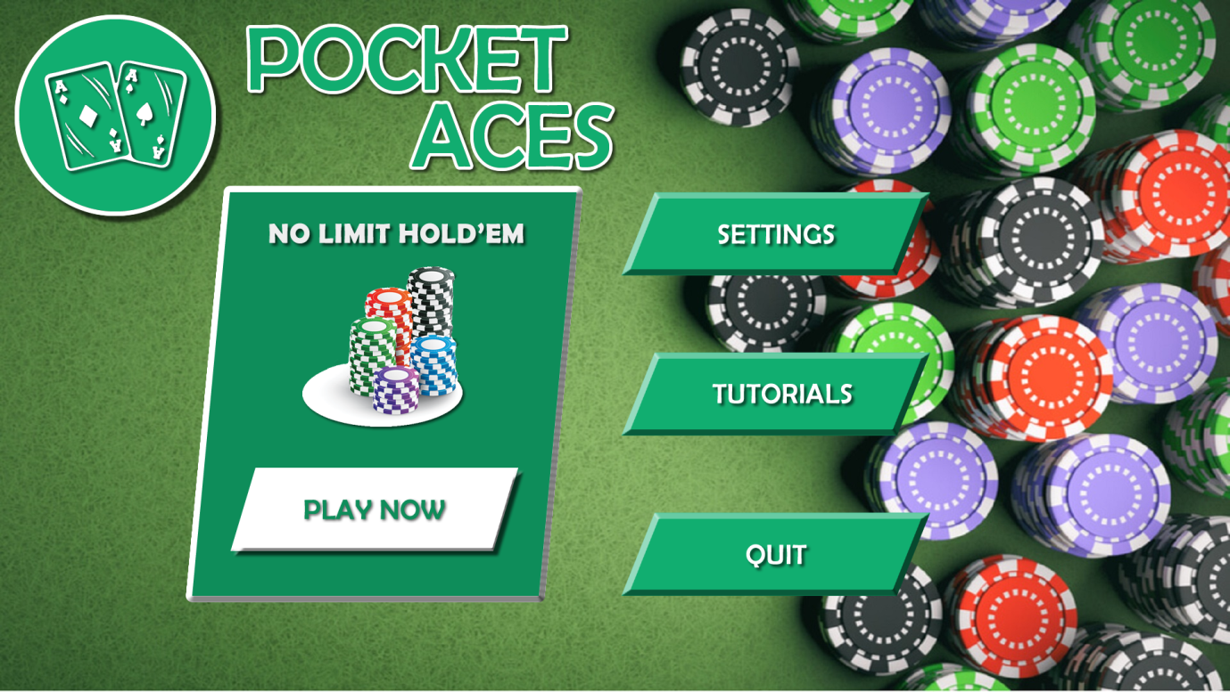The final iteration is shown in Figure . The background image and title have been kept the same due to positive user feedback. However all the buttons and blocks have been improved to parallelogram shapes and the colour scheme has been changed to contrast the green background which allows the title screen to be significantly more aesthetically enjoyable, which therefore does fulfil success criteria 12.

Figure

The “PLAY NOW” button has its own separate block to make it stand out to other buttons and is also in a different colour to all other buttons in order to draw the user’s attention to it. Inside the block is an image of chips and the label “No limit hold’em” which is a much shorter label than previously, so emphasises this iteration’s simplicity and ease of use for novice gamers. I chose to use chips as the image inside of the block, and not a set of cards because of the fact that the logo contains two ace cards, so having two similar images will look too repetitive.

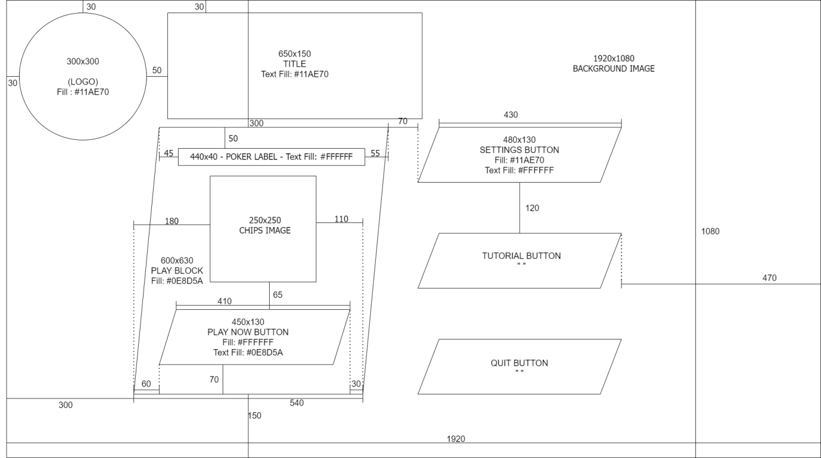**Wireframe:**

Figure

Large logo will be located in to top left of the screen - users are likely to immediately read from the top left of the screen.

Title relates to poker directly and is also large and central to enforce open communication with the user

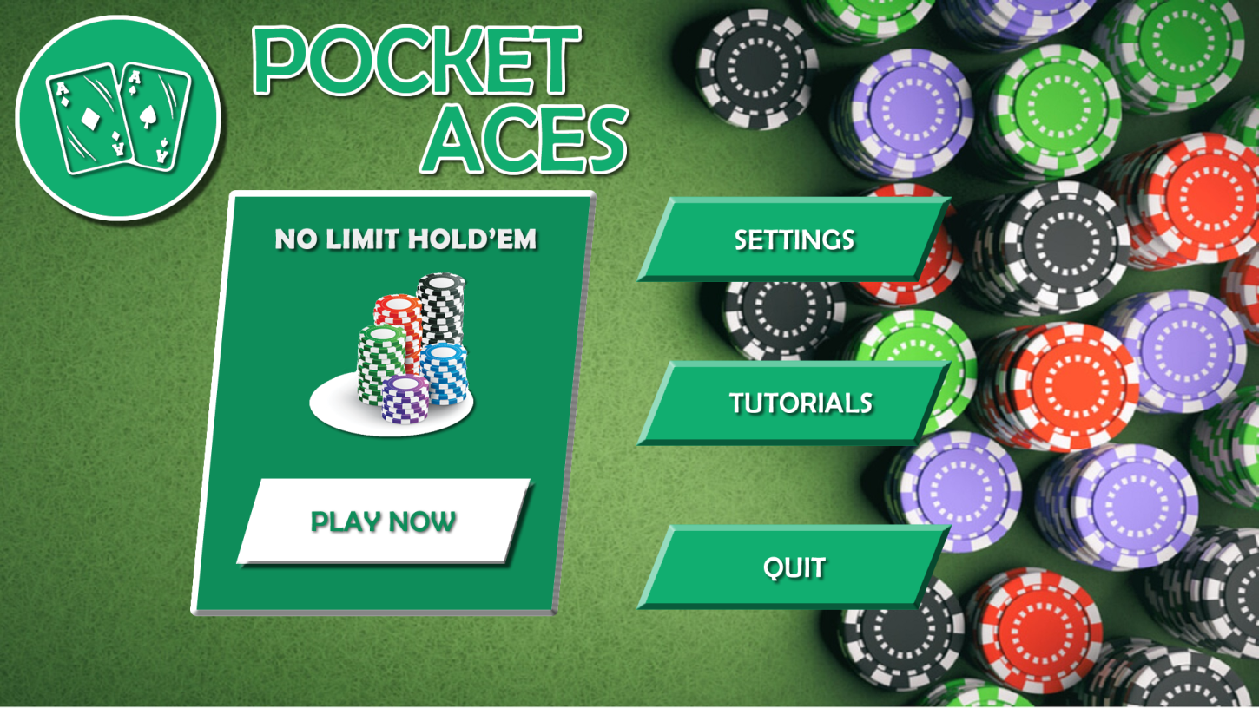

Darker tone of colour for block and using a white button creates clear separation between the two – making the play now button stand out and attract users attention

Label allows clear communication with the user, since it uses simple language that users will be able to understand

Separate block for “PLAY NOW” creates visual separation from other buttons.

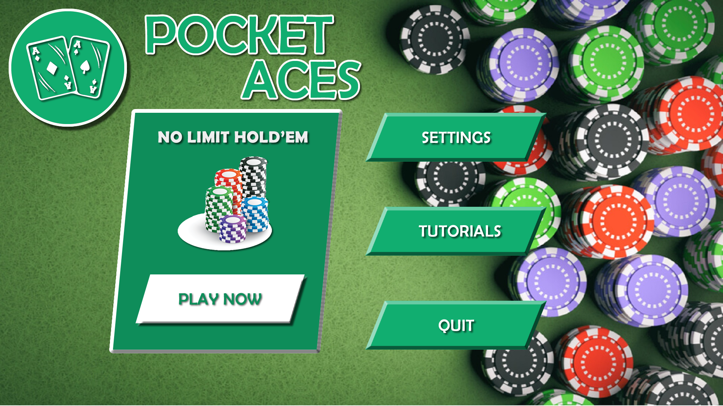

Image of chips is unambiguous and inexperienced users will be able to pick up

Background represents felt of a poker table with stacks of chips on it so immediately familiarises the user with the game.

Buttons have consistent colour and shape which improves learn-ability for the user.

Teal colour for buttons contrasts the green background well and does not blend into the background image.

##### gameplay screen

**Screen:**

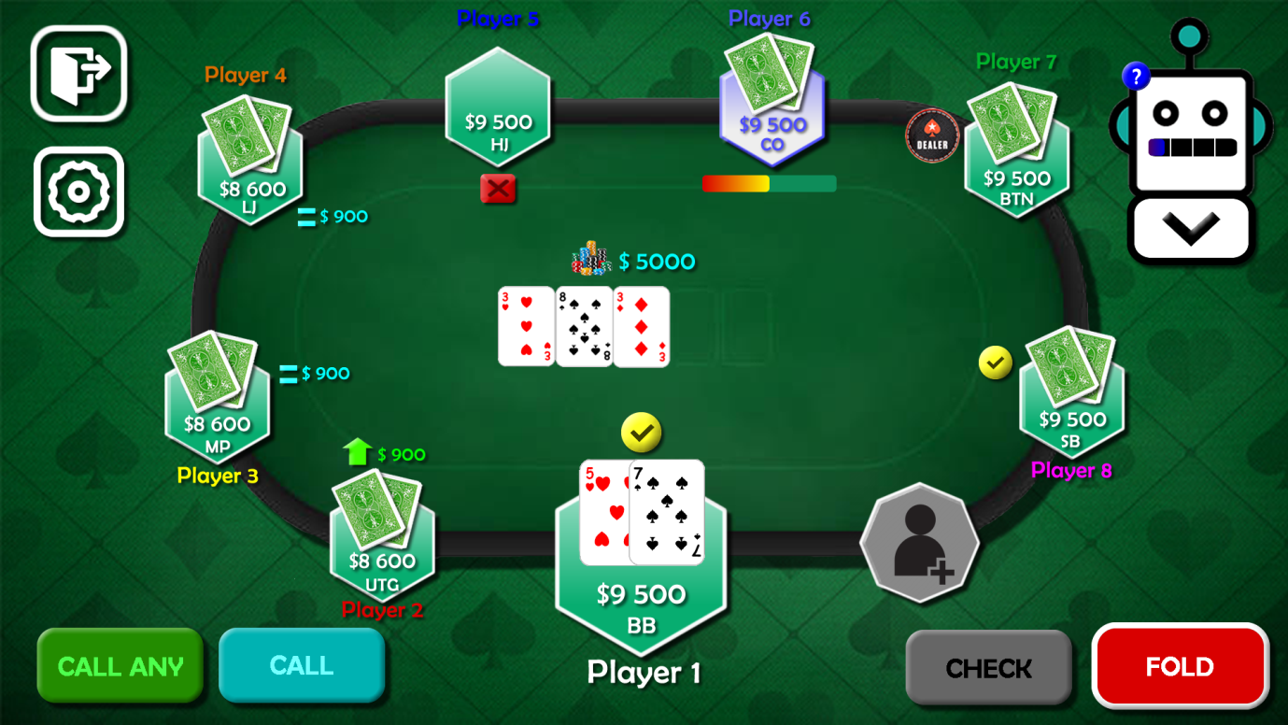

Figure

In Figure , the gameplay screen is shown. All information about each player is located in hexagonal shapes and each player is given an individual colour to create separation and distinction between each player. Furthermore, the fact that you can see the back of opponents’ cards helps to create a more realistic experience while also being a clear indicator that the opponent is in the current round. The community cards and pot being in the centre of the table also provide a true-to-life experience but are also the main focus of the screen. The pot is indicated by an icon of chips which communicates to the user that t

At the bottom of the screen are the pre-select buttons, and they are all different colours to ensure that they are unambiguous to fulfil success criteria . The pre-select button that is selected gains a white border and the text colour also changes to white – this makes it obvious to the user which button is selected. In addition, the check button is greyed out since the user cannot ‘check’ an opponent’s raise since this is an invalid move so this satisfies success criteria .

Also there are clear icons that demonstrate the action each player has taken – the yellow checkmark indicates check, green arrow represents raise, blue equal sign represents call and red cross indicates fold. The icons being different colours means they are straightforward to understand what action they represent, and the fact that the cards disappear once a player has folded reinforce this but also add realism since folding in real life poker is represented by giving your cards back to the dealer.

The hexagonal block changing colour and timer indicate whose turn it is. The timer bar changes colour from yellow to red to visually represent how much time they have left to make a move. The hexagonal block changing colour to white clearly shows whose turn it is since a visual change is much more likely to be picked up by inexperienced users. Where the seat is empty, the block changes to an octagonal shape and an add player icon is added to show that the seat is empty and can be filled.

Moreover the exit button is clear and obvious so that users are able to leave

The poker tutor is located in the top left and the probability bar is shown with a help icon. Users can use the help icon to get in context help which reduces the amount of information the users have to remember. The tutor also offers and extension button which shows all the complex probabilities and statistics which satisfies success criteria .

##### SETTINGS SCREEN

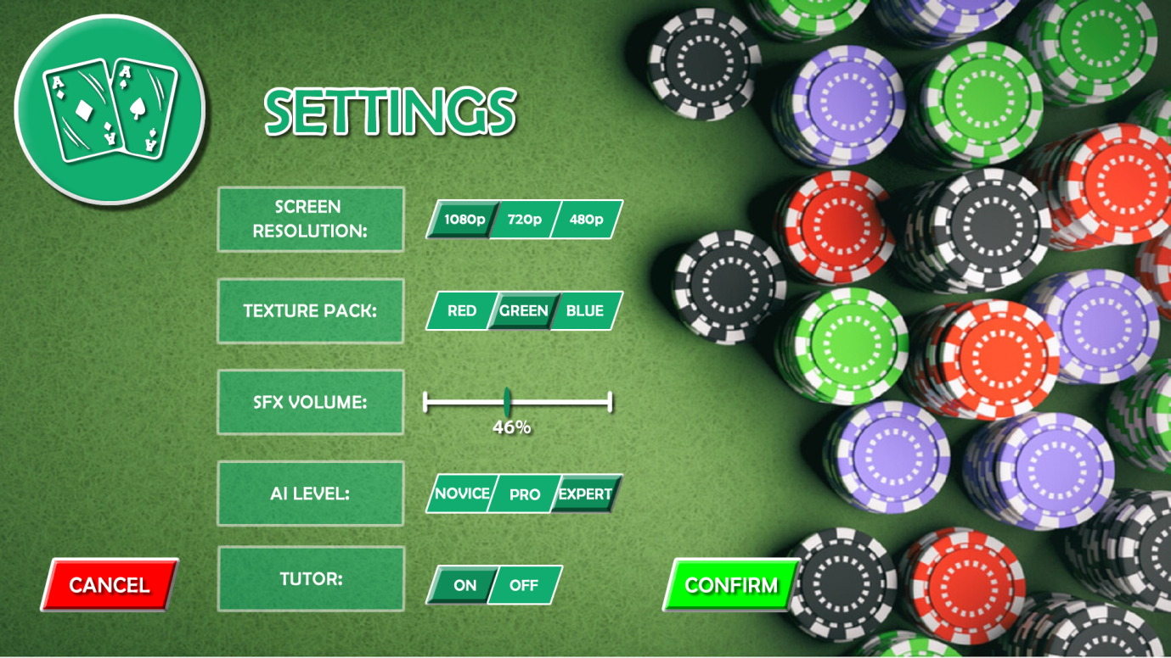**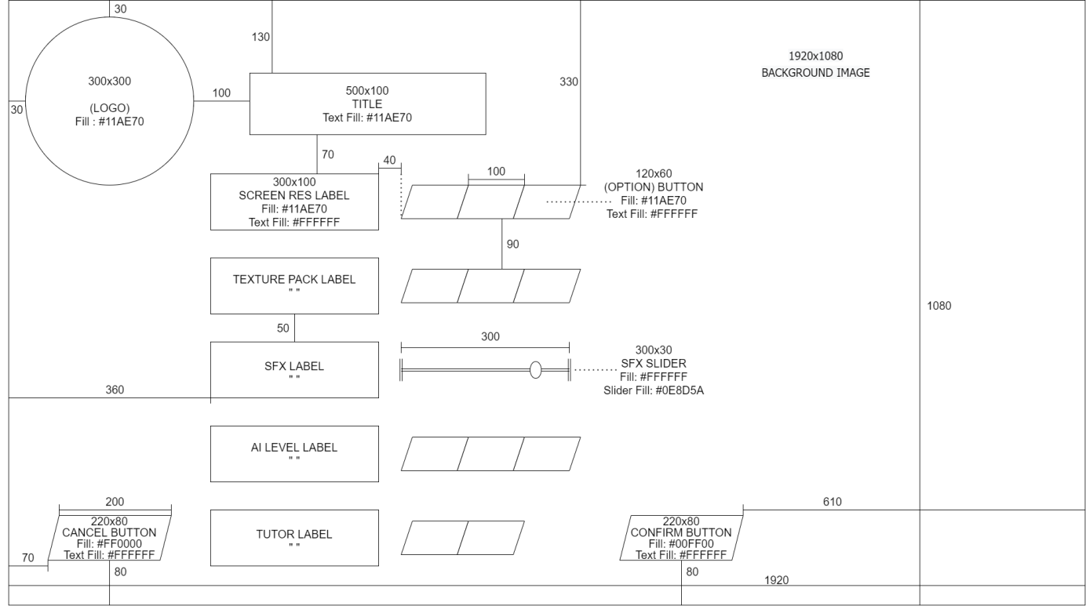Wireframe and screen**

Figure

Figure

In Figure , the settings menu is shown. The colour scheme, background, logo and button shape remains consistent with the title screen. This increases the internal consistency of my solution, meaning less experienced gamers will be able to learn how to navigate the menu quicker. Moreover, buttons and labels are different shapes to show a distinction between them to avoid any confusion for novice gamers.

The title ‘Settings’ at the top of the page means that the solution has clear communication to the user, which means that the user will always know which page they are on and how to navigate. This is reinforced by the cancel and confirm buttons – users will understand that these buttons will take them back to the title screen since that is where they have just came from. These buttons are also in colours that have external consistency – in general users will see the colour red as cancel or ‘go back’ and green as ‘go’ or confirm. If users have made changes to the settings and click cancel, a pop up will appear indicating that they have unsaved changes and asking them to validate their choice. This will mean that inexperienced users can recover from accidental mis-clicks easier. The pop up will also have a ‘Do not show again’ checkbox which is helpful for experienced users for whom the pop up might cause an inconvenience for.

Lastly the buttons indicate which option has been selected clearly by changing colour and an inner bevel which means users will be able to immediately know which option has been selected. Furthermore, users will not have to enter anything manually, and instead can change settings using sliders and buttons which reduce the chance of any input errors from inexperienced users. In addition, there are help buttons located on each label so if novice gamers are unaware of what a setting means, they can get in-context help which means that they are more likely to recall the information if they came back to the setting later on.

##### NEW GAME SCREEN

**Wireframe:**

Figure

**Screen:**

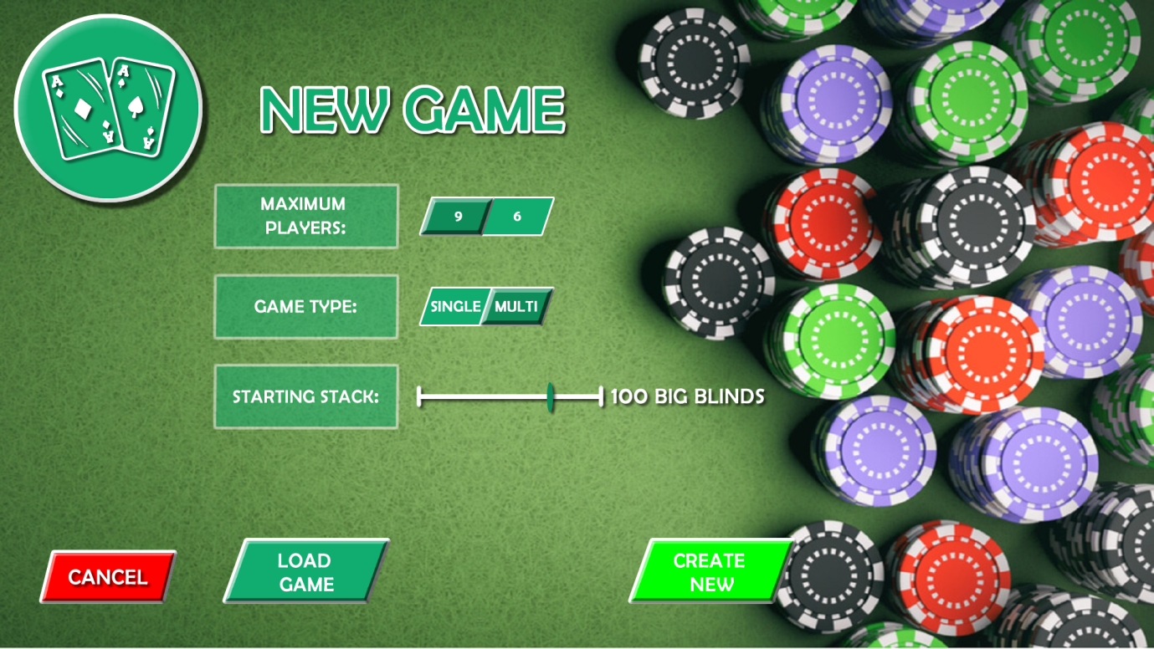

Figure

The new game screen is shown in Figure , and it follows a very similar layout to the settings screen. This is to ensure that there is internal consistency, since this will help inexperienced users familiarise themselves with the menu. The buttons are all unambiguous in order to satisfy success criteria , and the buttons also are visually different to the labels which will help users identify what they can or cannot press on the menu. In order to help novice gamers, users will be able to hover over the labels to get a brief overview of the setting they are changing. When the user clicks create game, they will be asked again if they are sure they want to create the game with the current settings. This will reduce the amount of ‘slips’ the user could experience on the screen and ensure that the less experienced users feel comfortable with the interface.

Furthermore, instead of having a separate screen to load a game, the load game feature is built into this screen so that a window of all the saved games appears once the user clicks on it. Reducing the amount of screens the interface has means that the menu is more efficient for users, since the user has to navigate less amount of unnecessary screens which means they can complete the wanted task in as few as steps possible.

Additionally, having a clear and discoverable cancel button means that user can easily find their way out of the screen with little inconvenience. Having a labelled ‘exit’ on the screen means that users spend less amount of time figuring out how to cancel the current interaction, which also reduces the chance of the users getting stuck and feeling frustrated.

##### Usability features

My design will always inform and communicate with users about which screen they are currently on and how to navigate between screens. When the user enters onto a different screen, the title of the screen is shown at the top of the screen, which will aid inexperienced end users since they are given clear feedback about what state the system is in. This is a key usability feature since users can learn what their actions do as well as predict the next steps to navigate the menu.

Furthermore, users will be warned about their actions before the solution completes them. For example, when the quit button is pressed, the user will have to confirm their action via a pop-up screen to ensure that the user intended to exit the game. This usability feature ensures users do not waste unnecessary time, for instance by accidently not saving setting changes, which directly prevents problems for the user and can aid inexperienced users get to grips with the design. In addition, the tutorial feature is an easy way for users to understand how to prevent their own errors and therefore can improve the experience for novice gamers who might struggle to learn controls on their own.

The overall aesthetic is very simple and minimalist to guarantee that the end user does not feel overwhelmed by different menu options which avoids confusion and allows the end user to build a connection with the menu. Irrelevant information is missed out of the menu which improves user and menu communication since relevant information is much easier to access. A minimalist design is an important feature since only essential features are highlighted and prevents inexperienced users getting distracted by unnecessary information.

A key feature of my UI design is the customizability. Users can choose from a variety of texture packs that can change backgrounds and colours of buttons or icons which is important to users as it gives them a sense of freedom.

Additionally, in order to help users recover from mistakes, each screen will have buttons that demonstrate in a straightforward way how to undo the unwanted action. If users find it easy to back out of a situation they did not want to enter it can improve their confidence and allow inexperienced users be in accordance with the user interface. Error messages will be expressed as simply and plainly as possible and also suggest ways to fix the problem to ensure that inexperienced users can recover from these errors. Furthermore, giving users a set of options to click means that users feel confident that whatever they enter will be valid, whereas inexperienced users might not know what to enter if they were given an entry field – promoting errors.

Moreover, giving the settings, new game, and tutorial screens a consistent layout and colour scheme improves the learn-ability of the user interface. This means that novice games will find the interface to be more usable and clear, and ensure that they feel like they can navigate the interface properly due to the internal consistency. Additionally, the game play screen follows conventions to other poker games; this means that there is also external consistency in my solution, which helps experienced users since they will be able to pick up the game’s controls and design quickly since they do not have to spend time learning a new layout.

Lastly all elements are visible which helps with memorability, since users will not have to invest time relearning the interface and how to use it properly. Instead of recalling information, users should be able to easily retrieve it using the interface which reduces the amount of cognitive effort that is required from users. One way that I will do this is by providing small ‘help’ buttons next to complex elements that inexperienced users might not be familiar with – offering users help in context enforces users’ ability to recall the information if they come back to it. Memorability ensures that the interface remains usable even if the user has not used the interface in a long period of time.

##### Screen resolution

I chose the default screen resolution of my game to be 1920x1080 for various reasons. Firstly, it is shown in Figure , that the majority of stakeholders will have this screen resolution, so therefore to satisfy the requirements for the majority of stakeholders it makes most sense to develop the game in a default resolution of 1920x1080.

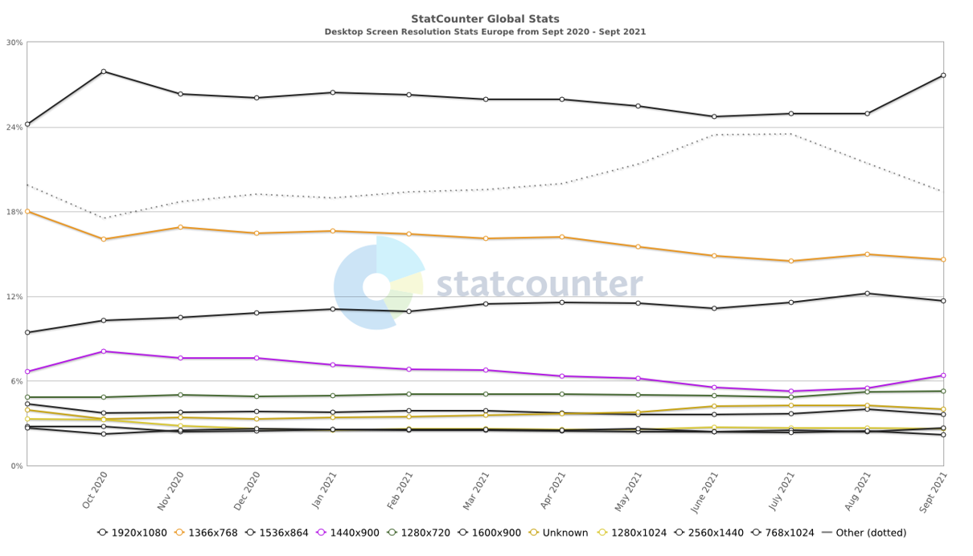

Figure [3]

Furthermore, 1920x1080 will be the screen resolution that I will be developing the game on – so the default screen resolution being the main development screen resolution will mean that the development process will become much easier and quicker. In addition, stakeholders will be able to choose from 2 other screen resolutions to find the right resolution for them. In conclusion since my solution will be for PC only, 1920x1080 is the most logical resolution since most desktop users have 1920x1080 as their native resolution.

### 2.2.2 Describing the Algorithms

#### 2.2.2. Dealing Cards

The deal method will take in two parameters: location (array) and amount (integer), and will deal ‘amount’ of cards to the specified ‘location’. This algorithm is required to the solution since at the start of each round cards will have to be dealt to all players. Furthermore, because the subroutine takes in a location as a parameter, dealing cards to each player as well as to the community pile is made extremely simple. Lastly, the subroutine ensures that any card that is dealt is also appended to the used array, to ensure that at the start of each round, the deck returns to its original 52 cards, with no repeats and no cards missing.

**Pseudocode algorithm:**

**PUBLIC PROCEDURE deal(amount, location)**  
 FOR i FROM 0 TO amount #repeating amount of times  
 index = random.randint (0, len(self.cards)) #choosing a random card  
 location.append(self.cards[index]) #adding the random card to location  
 self.used.append(self.cards.pop(index)) #removing card and adding card to used  
 END FOR  
**END PROCEDURE**

#### 2.2.2. Moving to the nExt Stage

The nextStage() subroutine will ensure that the next stage will only go ahead once every player is ready. If the next community card is dealt while a player has still not played their turn, this would be breaking the rules of poker and so would not be fulfilling stakeholder’s requirements. Therefore this subroutine is required to ensure that the solution is true-to-life, which is a key specification for experienced users.

**Pseudocode algorithm:**

**PUBLIC PROCEDURE nextStage()** #incrementing stage  
 TRY   
 self.stage = STAGES[STAGES.index(self.stage)+1]   
 EXCEPT IndexError #if we have reached the final stage  
 self.stage = STAGES[0] #set stage to the first stage  
 self.newRound() #call the method to start a new round  
 END TRY  
  
 #preparing each player for the next stage  
 FOR player IN allPlayers  
 IF player.position == “SB”  
 self.currPlayer = player.index #setting the action to the small blind  
 ENDIF  
 IF NOT player.folded #every player still in the round  
 player.ready = False #resetting attributes  
 player.currBet = 0  
 ENDIF  
 END FOR  
  
 #automatically dealing community cards  
 IF self.stage == “Flop”   
 DECK.deal(3, self.community)   
 ELIF self.stage == “Turn” OR self.stage == “River”  
 DECK.deal(1,self.community)  
 self.currBet = 0 #reset attributes  
**END PROCEDURE**

#### 2.2.2. Moving to the next round

Once a round has been completed – either one player remains or the showdown has been reached, a winner needs to be declared and then a new round needs to be started. Therefore this algorithm is important since it fulfils success criteria . Furthermore, if key attributes were not reset at the start of each round then the odds would not be realistic since there would not be a complete deck of cards, so the nextRound() subroutine ensures that success criteria () is also satisfied.

Moreover the subroutine automatically moves each player’s position along for the new round and therefore can automatically pay the blinds for the players in the big blind and small blind position. Therefore this fulfils success criteria () as it ensures that the game runs smoothly with no inconveniences. The subroutine also automatically deals everyone two cards so that no time is wasted between rounds and to minimize delays.

**Pseudocode algorithm:**

**PUBLIC FUNCTION nextRound()**  
 winner = allPlayers[self.calcWinner()] #find which player has won  
 winner.balance += pot #add the pot to the winners balance  
  
 #resetting the deck of cards  
 FOR card IN DECK.used   
 DECK.cards.append(card)   
 ENDFOR  
  
 #resetting key variables  
 DECK.used = []  
 self.community = []  
 self.currBet = 0  
 self.pot = 0  
  
 #preparing each player for new round  
 FOR player in allPlayers:  
 #incrementing player’s position  
 TRY   
 player.position = POSITIONS[POSITIONS.index(player.position)+1]  
 EXCEPT  
 player.position = POSITIONS[0]  
 END TRY  
  
 #automatically dealing blinds and setting current position  
IF player.position == “SB”   
 player.raise(self.bigBlind/2)  
 ELIF player.position == “BB”  
 player.raise(sel.bigBlind)  
 ELIF player.position == “UTG”  
 self.currPlayer = player.index  
 ENDIF  
  
 #resetting player’s attributes  
 player.hand = []  
 player.ready = False  
 player.currBet = 0  
 player.folded = False  
 DECK.deal(2,player.hand) #dealing them two cards  
 ENDFOR  **END FUNCTION**

#### 2.2.2. BEst Rank

Figure

One solution to calculating a hand’s best rank is to check for each rank in descending order of rank strength until one of your checks returns True. However, although this method appears to be simpler, it in fact is less efficient than other methods, since the majority of hands will have the best rank of either: pair, two pair or high card (the more common the hand is, the lower down it is in the rankings[4]). This algorithm would have to go through at least 6 checks just to get to two pair.

An alternate solution is to check the ranks in descending order of probability. However this solution would be extremely inefficient since each time the algorithm would run, a check would have to be done on all 9 ranks to be sure that the best rank has been found.

A more efficient algorithm is demonstrated in a flowchart shown in Figure . This algorithm is more efficient since it takes into account that some ranks are better versions of others – for example a four of a kind is just a three of a kind with an extra card of the same value. Therefore instead of having to check each individual rank every time, the algorithm can check a select few ranks and get to the best rank, on average, quicker. With this algorithm, there are only 3 checks required to get to pair, (an extremely common hand: occurs just under 50% of the time), so the majority of the time the new algorithm will be more efficient, since it will undergo less checks. Lastly, the demonstration of this algorithm in a form a flowchart will make the development process of this particular algorithm a lot easier and so will save time and effort.

This pseudocode algorithm requires separate subroutines to run. This is because some subroutines, such as hasFlush(), are called multiple times within this algorithm, and so having each rank checker as a separate subroutine reduces the amount of code and ensures that the algorithm remains simple and clear to understand and follow which will help the development stage greatly.

**Pseudocode algorithm:**

**PUBLIC FUNCTION bestRank(community)** totalCards = self.hand + community #combining community cards and hole cards straight = self.hasStraight(totalCards) #do they have a straight  
 IF straight <> [] #if they have a straight  
 answer = self.hasStraightFlush(totalCards, straight) #checking if they have a straight flush, flush or just a straight  
 ELIF self.hasSameCard(totalCards, 3) #if they have AT LEAST a three of a kind  
 IF self.hasSameCard(totalCards, 4) == “Exact” #if they have EXACTLY a four of a kind   
 answer = “Four of A Kind”  
 ELIF self.hasSameCard(totalCards,2) == “Exact” #if they have EXACTLY a pair – therefore they must have a full house  
 answer = “Full House”  
 ELIF self.hasFlush(totalCards) <> “” #if they have a flush  
 answer = “Flush”  
 ELSE  
 answer = “Three of A Kind”  
 ENDIF  
 ELIF self.hasFlush(totalCards) <> “”#if they have a flush  
 answer = “Flush”  
 ELIF self.hasSameCard(totalCards, 2) #if they have AT LEAST a pair  
 IF self.hasTwoPair(totalCards) #if they have a two pair  
 answer = “Two Pair”  
 ELSE  
 answer = “Pair”  
 ELSE #if they have no other rank  
 answer = “High Card”  
 END IF  
 RETURN answer  
**END FUCNTION**

The hasFlush subroutine will check if the hand has five cards of the same suit. It is important to the bestRank algorithm since it is called upon many times system works – see Figure - and so is required to complete the solution to the problem.

**Pseudocode algotithm:**

**PUBLIC FUNCTION hasFlush(totalCards):**  
 suits = ["C","D","H","S"]  
 answer = “”  
 cardSuits = []  
  
 #creating an array of just suits  
 FOR card in totalCards  
 cardSuits.append(card.suit)  
 ENDFOR  
  
 #repeating for every suit  
 FOR suit IN suits  
 IF cardsSuits.count(suit) >= 5: #if there are at least 5 of the same suits  
 answer = suit #then they have a flush  
 ENDIF  
 ENDFOR  
 RETURN answer  
**END FUNCTION**

The subroutine hasSameCard will check if the hand has any cards of the same value. The parameter ‘amount’ specifies the amount of cards that the hand needs to be in order to fulfil the rank that is being checked and therefore should be an integer between 2 and 4. For example, when checking a three of a kind, amount should be passed in as 3. This subroutine is vital to the bestRank algorithm and so helps to form a complete solution to the problem.

**Pseudocode algorithm:**

**PUBLIC FUNCTION hasSameCard(totalCards, amount)**  
 answer = False  
 cardsValue = []  
  
 #creating an array of just values  
 FOR card in totalCards   
 cardsValue.append(card.value)  
 ENDFOR  
  
 #repeating for every card  
 FOR card in cardsValue  
 count = cardsValue.count(card) #counting how many cards of the same value  
 IF count == amount #if they have the exact required amount of same valued cards  
 answer = “Exact”  
 ELIF count > amount #if they have at least the required amount of same valued cards  
 answer = True  
 ENDIF  
 ENDFOR  
 RETURN answer  
**END FUNCTION**

The subroutine hasStraight is needed by the bestRank algorithm since it is the first rank that gets checked. This is because the algorithm for checking if a hand has a straight is long and complex and so calling this subroutine multiple times would reduce the overall efficiency of the bestRank algorithm.

**Pseudocode algorithm:**

**PUBLIC FUNCTION hasStraight(totalCards)**  
 cardsValue = []  
 answer = []  
  
 #creating an array of just values with NO repeats  
 FOR card in totalCards   
 IF card.value NOT IN cardsValue  
 cardsValue.append(card.value)  
 ENDIF  
 ENDFOR  
  
 #if there is an ace in the deck, make sure it can be treated as a ‘1’ in a straight  
 IF 14 in cardsValue  
 cardsValue.append(1)  
 ENDIF  
   
 #if there are more that 5 cards to look from – a straight is possible  
 IF len(cardsValue) >= 5:  
 cardsValue.sort() #sorting the values  
 #repeating for the amount of straight combinations there are  
 FOR start FROM 0 TO (len(cardsValue)-4) #there are (length -4) combinations of 5 cards  
 straight = False #defines if these 5 cards make a straight  
 FOR index FROM start TO start+4 #repeating for the 4 out of 5 cards  
 IF cardsValue [index+1] -1 <> cardsValue [index] #if the card is not connected to the next card  
 straight = False  
 BREAK  
 ENDIF  
 ENDFOR  
 IF straight #if these cards made a straight  
 answer = cardsValue[start:start+5]  
 ENDIF  
 END FOR  
 ENDIF  
 RETURN answer  
**END FUNCTION**

If a straight has been found, the bestRank algorithm must check if this straight forms a straight flush, which is why the hasStraightFlush algorithm is required. The algorithm checks if all the cards in the straight are of the same suit – if they are then a straight flush has been found – this is important since a straight flush is a higher rank than a straight, so it should be checked before we can conclude if the best rank is a straight or not.

**Pseudocode algorithm:**

**PUBLIC FUNCTION hasStraightFlush(totalCards, straight)**  
 suit = self.hasFlush(totalCards) #checking if they have a flush  
 answer = False  
 count = 0  
  
 #if they do have a flush  
 IF suit <> “”  
 #checking if the straight and the flush coincide (to give straight flush)  
 FOR card in totalCards  
 IF card.value IN straight AND card.suit == suit   
 count += 1  
 ENDIF  
 ENDFOR  
  
 #deciding which rank they have  
 IF count >= 5  
 answer =”Straight Flush”  
 ELSE  
 answer = “Flush”  
 ENDIF  
 ELSE #if they didn’t have a flush  
 answer = “Straight”  
 ENDIF  
 RETURN answer   
**ENDFUNCTION**

The hasTwoPair() subroutine checks if there is more than one pair – once the bestRank algorithm has found one pair, it must check fi there are two pairs since a two pair is a higher rank that a single pair so must be checked in order for the algorithm to be accurate. Therefore this algorithm is required to form a complete solution to the problem of finding out the best rank.

**PUBLIC FUNCTION hasTwoPair(totalCards)**  
 answer = False  
 cardsValue = []  
 used = []  
  
 #creating an array of just values  
 FOR card in totalCards   
 cardsValue.append(card.value)  
 ENDFOR  
  
 #repeating for every card  
 FOR card in cardsValue  
 count = cardsValue.count(card) #counting how many cards with the same value  
 IF count == 2 AND card NOT IN used #if there is a NEW pair  
 amount += 1  
 used.append(card)  
 ENDIF  
 ENDFOR  
 IF amount >= 2: #if there are two distinct pairs  
 answer = True  
 RETURN answer  
**END FUNCTION**

#### 2.2.2. EXPECTED VALUE

Expected value is the profit you expect to get in the long run for a certain action (for example call or raise). To calculate the expected value you must use the formula:

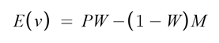Where P is the pot size, W is the equity and M is the amount to call. The reciprocal of the x-intercept is the pot odds.

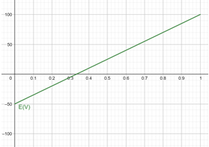

Figure

In Figure , the graph of expected value (EV) is shown with the pot size of 100 and the amount to call is 50. The graph shows a linear relationship between EV and equity. For low equity, the EV is negative and therefore you are expected to make a loss if you call in the long run. For higher values of equity the EV is positive and so you are expected to make a profit. The x-intercept shows the minimum equity needed for the action to be profitable and the reciprocal of this equity is known as the ‘pot odds’ which is a ratio of the amount to call to the pot size.

EV will be a key statistic that the Poker Tutor will display. A significant part of Poker is consistently making +EV plays. If the Poker Tutor displays the EV, it will allow inexperienced players to get better at the game since they are making better decisions. Also the Poker Tutor should be able to suggest tips which fulfils success criteria 9 and the EV will be a statistic that the Poker Tutor can use to suggest an appropriate move based on whether the play is +EV or –EV.

The subroutine calcEV will calculate both expected value and pot odds in order to make the code as simple as possible. If each statistic had its own subroutine, it would reduce the efficiency of the code since there would be unnecessary subroutines that would have to be called. Pot odds can be calculated using the same variables required by expected value, so it makes logical sense to calculate them using a single subroutine to improve efficiency.

**Pseudocode algorithm:**

**PUBLIC FUNCTION calcEV(potSize, equity, amCall)**  
 EV = ((potSize+amCall)*equity) – amCall

potOdds = potSize/amCall   
 return EV, potOdds  
**END FUNCTION**

#### 2.2.2. Cards Available

In order to calculate probabilities for each rank and equity, an array of cards needs to be made that includes all cards apart from cards that the player knows is not in the deck (their own hole cards and the community cards). Therefore the remCards() subroutine is needed to generate this array of cards, in order to form a complete solution.

**Pseudocode algorithm**

**PUBLIC FUNCTION remCards ()** allCards = DECK.cards[:] + DECK.used[:] #full deck of 52 cards  
 totalCards = allPlayers[index].hand[:] + ROUND.community[:] #all cards that you can see  
  
 #removing the cards you can see from the total deck  
 FOR card in allCards:  
 FOR each in totalCards  
 IF card.suit == each.suit and card.value == card.value allCards.remove(card)  
 ENDIF  
 ENDFOR  
 ENDFOR  
 RETURN allCards **ENDFUCNTION**

#### 2.2.2. Equity

 Equity is the approximate win percentage at a given stage and is based on the number of ‘outs’ you have. ‘Outs’ refers to any card that significantly improves your hand or completes a draw. For example needing a King to complete a straight draw would give you 4 outs since there are 4 kings in the deck.

On turn to river, the Equity is just the number of outs divided by 46 since you can assume there are 46 cards left in the deck (4 community cards, and 2 hole cards). When plotted on a graph the number of outs is proportional to the equity as shown in Figure.

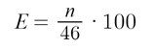

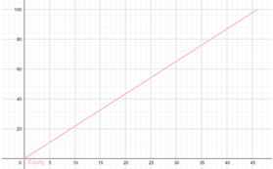Where E is the equity and n is the number of outs.

Figure

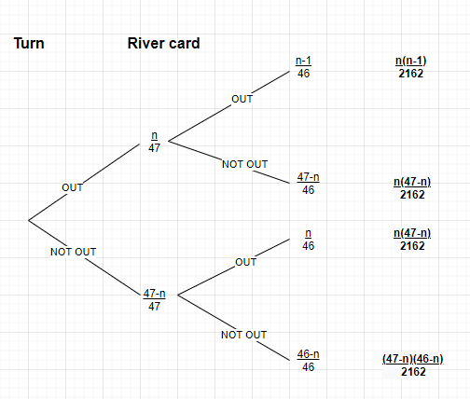However on flop to turn, the equity is more complicated since there are two more cards to come. A helpful demonstration of this problem is a probability tree (shown in Figure ), that shows the probability of getting n, amount of outs on the turn card and river card.

Figure

In Figure , these probabilities are shown in a table. The column Flop to Turn shows the probabilities of getting n amount of outs on the turn which is calculated by n/47. Similarly Turn to River is calculated by dividing the number of outs by 46. Turn and River is calculated by finding the probability of getting no outs on the river and no outs on the turn, then subtracting this probability from 1 to get the probability that you do get an out. Simplifying this, gives the formula for achieving at least one out on the turn or river:

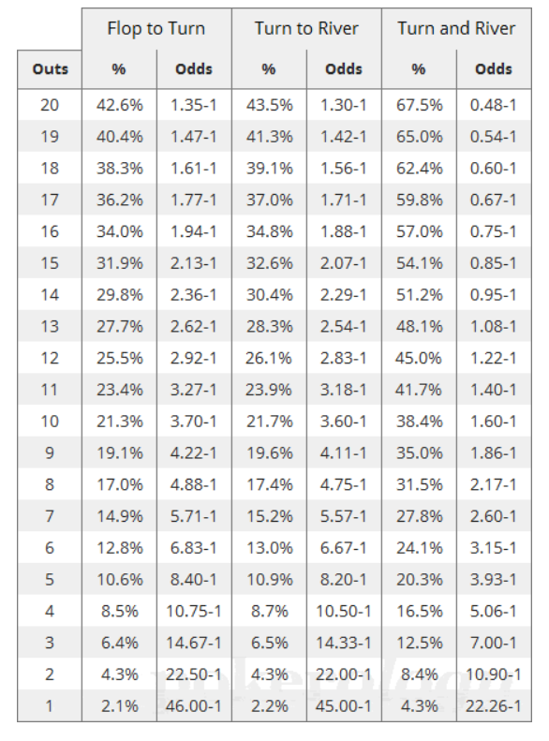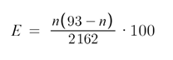Where E is the equity and n is the number of outs

Figure

Equity is a key statistic in poker since it is required in many other statistics and so it is important to have a fundamental statisitc. Furthermore the equity can be used to suggest tips (higher equity means likely to win) so fulfils success criteria 9. Also novice gamers will appreciate having an easy win percentage statistic as they can easily interpret this statistic – therefore, equity meets the stakeholder’s requirements.

**Pseudocode algorithm:**

**PUBLIC FUNCTION calcEquity(index, stage)** outs = 0  
 currRank = allPlayers[index].bestRank(ROUND.community) #finding our best rank  
 remainingCards = allPlayers[index].remCards() #finding the remaining cards  
 #repeating for each remaing card  
 FOR card IN remainingCards  
 highestRank = allPlayers[index].bestRank(ROUND.community + [card])  
 IF RANKS[highestRank] > RANKS[currRank] #if the card gives us a better rank  
 outs += 1 #then it is considered an out  
 ENDIF  
 END FOR  
  
 #calculating equity using given formula  
 IF stage == "Flop"  
 equity = (outs*(93-outs))/2162  
 IF stage == "Turn"  
 equity = (outs/46)*100  
 ENDIF  
 RETURN equity, outs  
**END FUNCTION**

##### Outs

As mentioned above, outs refer to the number of cards remaining in the deck that give your hand the desired rank. The number of outs is the fundamental statistic in poker as it allows all other poker statistics to be calculated and so it is required that the poker tutor calculates and displays the number of outs. The poker tutor must be able to show users the complex probabilities and statistics sa required by success criteria and stakeholders, so calculating these outs is a necessary is a necessary algorithm that helps to form a complete solution to the problem that is helping inexperienced poker players getting better at poker.

**Pseudocode algorithm**

**PUBLIC FUNCTION calcOuts(index, stage)** #creating a dictionary for each rank with number of outs as the values  
 rankOuts = {}  
 FOR each IN RANKS  
 rankOuts[each] = 0  
 ENDFOR  
  
 remainingCards = allPlayers[index].remCards() #finding the remaining cards  
 IF stage == “Flop”  
 copyDeck = remainingCards[:] #making a replica of the remaining deck  
 FOR riverCard IN remainingCards  
 turnCard = copyDeck.pop(copyDeck.index(card))) #removing the turn card from the copied deck  
 FOR riverCard IN copyDeck  
 highestRank = allPlayers[index].bestRank(ROUND.community + [turnCard,riverCard]) #finding the best rank including the two new cards that we have added  
 rankOuts [highestRank] += 1 #adding an out to whichever rank we found  
 ENDFOR  
 copyDeck.append(turnCard) #adding back the card we previously removed  
 ENDFOR  
 ELIF stage == “Turn”  
 FOR riverCard IN remainingCards  
 highestRank = allPlayers[index].bestRank(ROUND.community + [riverCard]) #finding the best rank including the new card we added  
 rankOuts [highestRank] += 1 #adding an out to whichever rank we found  
 END FOR  
 RETURN rankOuts **END FUNCTION**

#### 2.2.2 Each rank

The Poker tutor must be able to display the probabilities of achieving each rank since this fulfils success criteria , where inexperienced users require the ability to see the complex probabilities.

The method for achieving this is similar to calculating equity: you calculate the number of outs to achieve a rank and based on the stage of the round, you can calculate the probability. On the turn, the method is the exact same, but with a different number of outs that correspond to the rank we are calculating.

The probability of each rank allows inexperienced players to familiarise themselves with how strong certain hands are and the rank hierarchy. Therefore the algorithm to calculate the probability for each rank is needed in order to help novice players get batter at poker, which completes the Poker Tutor and its solution to the problem of increasing inexperienced players skill level.

**Pseudocode algorithm:**

**PUBLIC FUNCTION eachRank(index)** ranksProbs = {}  
 IF ROUND.stage == “Flop”  
 rankOuts = calcOuts(index, “Flop”) #calculates the outs for each rank  
  
 #calculating the probability for each rank  
 FOR each IN rankOuts  
 rankProbs[each] = (rankOuts[each] /2162)*100   
 ENDFOR  
 ELIF ROUND.stage == “Turn”  
 rankOuts = calcOuts(index, “Turn”) #calculates the outs for each rank  
  
 #calculating the probability for each rank  
 FOR each IN rankOuts   
 rankProbs[each] = rankOuts[each]/46  
 ENDFOR  
 ELIF ROUND.stage == “River”  
 #the best rank has 100% probability on the river and the other ranks have 0  
 FOR each IN RANKS  
 rankProbs[each] = 0  
 ENDFOR  
 highestRank = allPlayers[index].bestRank(ROUND.community)  
 ranksProbs[highestRank] = 100   
 ENDIF  
 RETURN ranksProb  
**END FUNCTION**

#### 2.2.2. Calcuating the winner

At the end of each round a winner must be calculated and the pot must be given to them. This is because this follows the real life rules of poker and also satisfies success criteria . The calcWinner() subroutine is also required by other algorithms so helps to complete the solution. It is important that a winner is calculated and that that winner is

**Pseudocode algorithm**

**PUBLIC FUNCTION calcWinner()** winnerRank = -1  
  
 #for each player who has not foldedFOR player in allPlayers  
 IF NOT player.folded  
 rankName = player.bestRank(self.community) #calculate their best rank  
 rankValue = RANKS[rankName]  
 IF rankValue > winnerRank #if it’s better than the previous best rank  
 winnerRank = rankNum  
 index = player.index  
 END IF  
 END IF  
 END FOR  
 RETURN index **END FUNCTION**

#### 2.2.2. Next Player

After each player completes their action, the action must move to the next player who has not folded. The subroutine also ensures that if the action has completed in this stage, the round should move on to the next stage. This is important since this subroutine will allow the game to continue as per the rules of poker and guarantee that no player misses their turn which would be unfair to users. The algorithm is important to the solution as it allows constant progress of the game.

**Pseudocode algorithm:**

**PUBLIC PROCEDURE nextPlayer(index)** index += 1player = allPlayers[index]  
 #finding the next player who has nor folded  
 WHILE player.folded  
 index += 1  
 TRY  
 player = allPlayers[index]  
 EXCEPT  
 player = allPlayers[0]  
 index = 0  
 END TRY  
 END WHILE  
 #checking to see if we need to move to the next stage  
 IF allPlayers[index].ready  
 self.nextStage()  
 ELSE  
 self.currPlayer = index  
 ENDIF  
**END PROCEDURE**

#### 2.2.2. actions

Actions are the moves that a player can make at their turn. Each subroutine gets called when the user clicks on the respective button. The subroutines must validate the move, carry out the move and then move the action to the next player and so are key in ensuring that players can only play valid moves – completing success criteria .

##### Check

**Pseudocode algorithm:**

**PUBLIC PROCEDURE check():** IF ROUND.currBet == 0:  
 self.currBet = 0  
 self.ready = True  
 ROUND.nextPlayer(self.index)  
 ENDIF **END PROCEDURE**

##### FOLD

**Pseudocode algorithm:**

**PUBLIC PROCEDURE fold():**  
 self.ready = True  
 self.currBet = 0  
 ROUND.nextPlayer(self.index)  
 self.folded = True **END PROCEDURE**

##### raise

**Pseudocode algorithm:**

**PUBLIC PROCEDURE raise(amount)** IF amount >= self.balance #ALL IN  
 self.ready = True  
 self.currBet = amount  
 self.balance = 0  
 ROUND.pot += amount  
 ROUND.nextPlayer(self.index)ELIF amount >= ROUND.currBet * 2 #valid raise  
 FOR player IN allPlayers  
 IF player.balance <> 0 OR NOT player.folded  
 player.ready = False  
 ENDIF  
 ENDFORself.ready = True  
 self.currBet = amount  
 self.balance -= (amount – self.currBet)  
 ROUND.currBet = amount  
 ROUND.pot += amount  
 ROUND.nextPlayer(self.index)  
 ENDIF **END PROCEDURE**

##### Call

**Pseudocode algorithm:**

**PUBLIC PROCEDURE call()** amount = ROUND.currBet  
 IF self.balance <= amount #ALL IN  
 self.raise(self.balance)ELIF self.balance > amount  
 self.ready = True  
 self.currBet = amount  
 self.balance -= (amount – self.currBet)  
 ROUND.pot += amount  
 ROUND.nextPlayer(self.index)  
 ENDIF **END PROCEDURE**

##### FORCE

The force() subroutine will be called when the player runs out of time. It fulfils success criteria which ensure that the game runs smoothly and continues even if a player has stopped playing or misses a move. The subroutine automatically plays the safest move, so that if the user were to come back to the game they would be caused the least inconvenience.

**Pseudocode algorithm:**

**PUBLIC PROCEDURE force()** IF ROUND.currBet = 0  
 self.check()  
 ELIF ROUND.currBet > 0  
 self.fold()  
 ENDIF **END PROCEDURE**

### 2.2.4 Identifying key aspects

#### 2.2.4.1 FIle Design

In Figure , the file design for all the solutions required entities is shown. The entites folder is responsible for storing and images or assets that the solution requires.

The Entities folder is split up into subfolders according to the type of entity they are (for instance, button entities are in the ‘Buttons’ subfolder). This is an efficient way of organising the assets and will help in the development stage – during programming, if I need an asset, it would be straightforward as to where to find the desired asset.

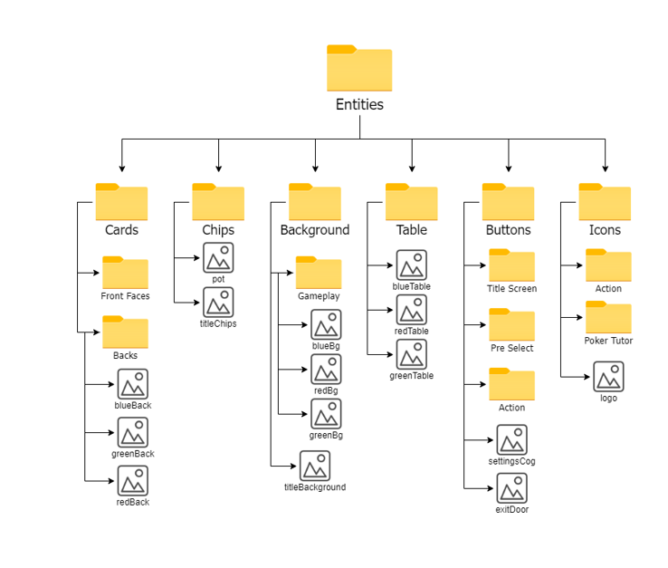Furthermore, there are no repeating folders or image names, which avoid any confusion during the development stage. For example, if the entities were split into two subfolders: Title Screen and Gameplay, each subfolder would share folder names such as ‘Buttons’ or ‘Icons’ which could lead to accessing incorrect folders during the development stage.

Figure

#### 2.2.4.2 Key variables and constansts [5]

|  |  |  |
| --- | --- | --- |
| **Name** | **Data Type** | **Purpose & Justification** |
| allPlayers | Array | The variable stores each player’s object. Each player can be easily accessed within the array and subroutines that require checks on each individual player can be efficiently done so using this array (for example the nextRound() method). Also allows the addition of new players easily and can keep track of whose turn it currently is and who the next players turn is. |
| FONTNAME | String | Stores the name of the font the game will be primarily using. Helps the development stage since long font name can be referenced easily through one variable so saves time and effort. |
| MAINCOLOUR | String | Stores the hex of the colour the game will be primarily using. Helps the development stage the hex can be referenced easily through one variable so saves time and effort. |
| STAGES | Array | Each stage needs to be stored in an array so that when the round is moved to the next stage, the name of the next stage can easily be found since the stage attribute can be incremented and then correspond to a stage. |
| allPositions | Array | Stores all the positions of the current table. Storing all the positions in one single array makes the development stage easier since when the next round begins, each player’s position can be incremented and correspond to a position in the array. Furthermore, when a player leaves, a position can be removed from the array so that when the positions are iterated, they remain correct which is simpler than having to individually change each player’s position attribute manually. |
| MAX9  MAX5 | Arrays | Store all the positions for the 9 max or 5 max table. The respective array will be copied into the allPositions variable at the start of each game. |
| RANKS | Dictionary | Stores all the names of the ranks as keys and their values correspond to ho strong the rank is. This means that ranks can be explicitly compared with each other using their corresponding value which means that a round winner can be calculated with ease. |

## 2.3 Approaching the Testing

### 2.3.1 The Test Strategy

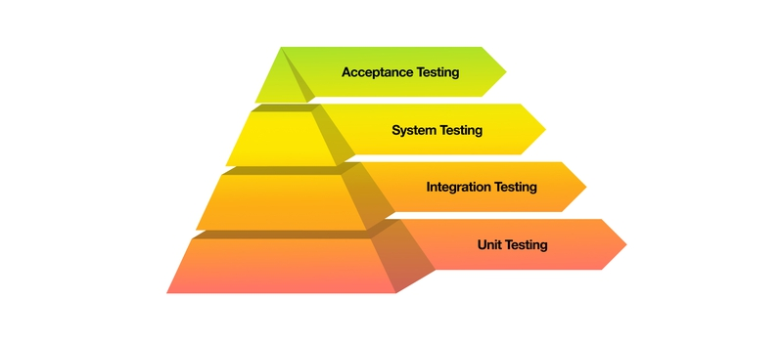I will be testing my program in four stages to ensure that the solution is functional and meets all the requirements outlined by my stakeholders. In Figure , the four stages that I will be using to test my solution are shown, and they are significant since each stage will allow me to ensure that all my success criteria are met. The Figure shows the testing style approach I will be taking, which is a ‘bottom up’ approach since each stage will make the next stage above easier, which is the most efficient approach since it saves time and effort.

Figure

#### 2.3.1.1 unit testing

Each subroutine will be tested independently using white box testing to identify any bugs or issues within each unit. This means that the appropriate changes can be made to fix any issues within each module that is currently being tested, so increases the efficiency of the testing process since bugs can be traced back to their source immediately. I will be testing units throughout the development stage to ensure base functionality. I will carry out unit testing using test data on specific units.

Unit testing is a vital stage since each unit is isolated so that it can be checked to see if it misses and part of the specification or has any flaws. Units are the smallest testable part of the program and so by undergoing modular testing, the quality of code can be improved and allows the code to be reusable and reliable. Unit testing is a key part of my approach of testing, as it allows integration of the separate modules and makes integration testing easier due to the ‘bottom up’ nature of my approach. Unit testing also speeds up the process of testing since all other stages are made significantly easier – bugs found in modular testing can be found quicker and resolved faster than if they were found in later stages of testing, for example if they were found during system testing.

Since I am using object orientated programming, I will be testing each method separately as methods are the smallest testable area of my solution. Each method in each class will be tested using various test data to ensure that they produce they required output (black box testing). Each module is isolated to ensure that it meets its specification and to ensure efficiency (using white box testing) before being integrated.

#### 2.3.1.2 Integration testing

After each unit has been tested separately, it is important to test if each unit is able to incorporate other units and maintain its functionality. Two or more modules should be combined and tested as a group using a bottom up approach. This means that the lower level modules will be tested which allows the next higher level component to be tested – the process repeats until the top of the hierarchy has been reached. The lowest levels will be isolated and tested in the unit testing stage, and then integrated and tested as a group. I will carry out integration testing using trace tables and setting a trace on multiple modules.

Integration testing will allow system testing to be completed and so is a key stage of testing. This type of testing will ensure that modules work in an integrated way and can detect errors that only appear when modules are grouped together, which are errors that unit testing overlooks. Integration testing also ensures that further stages are simplified and saves time in the system testing stage and allows it to be properly completed.

Since I have defined each unit as each subroutine, integration testing should test each class which groups the subroutines together. For example, the methods that the bestRank() method requires will be individually tested in the unit testing stage; then they will be integrated and the bestRank() method will then be tested to ensure functionality. Then the class “Player” will be tested using all of its methods to ensure that they produce the right output but also are efficient (gray box testing).

#### 2.3.1.3 System testing

System testing verifies that the entire integrated solution meets with the criteria and requirements that were set out in the analysis section. The functional and non-functional parts of the solution are tested for the first time in this phase which means that the solutions quality requirements are met before advancing to the next phase of testing.

I will test for functionality to ensure that the solution works as per the requirements defined within the capabilities of my solution – this will ensure that any bugs or flaws missed by previous stages can be reported and fixed before the final stage of testing. I will also test for how well the solution reacts and responds to input errors and other failure situations to test how well the solution can recover from possible errors – improves the reliability of the solution. System testing also ensures that the solution’s usability features are included and these can be tested and improved on.

Furthermore, any defects or issues that have not been revealed in the previous stages will be picked up in the system testing stage – for example, there are numerous complex scenarios that integration testing will have overlooked that will be found during this phase. The testing of both functional and non functional requirements is important to ensure that all success criteria are being met and that stakeholders feel that their requirements are being to.

#### 2.3.1.4 Acceptance Testing

Acceptance testing will assess my solutions compliance with the specified requirements. It ensures that the solution meets with all the success criteria and the stakeholder’s requirements. I will carry out acceptance testing using alpha testing using stakeholders as testers, who will carry out black box tests – they will only be testing the functionality of the solution and not the efficiency, since my stakeholders will not have any knowledge of any programming or design. Alpha testing will identify all possible issues, since stakeholders will carry out various tests and report and bugs or flaws that the solution may have.

Acceptance testing will ensure that the probability of a failure or risk later on is greatly reduced, and directly involves the stakeholders so that their requirements can be met. In addition, system testing allows the end user to understand the solution and its features, and end user feedback can help specify how the application should behave as well as allowing changes to be made to existing features.

Moreover, acceptance testing will guarantee that the solution is working according to the requirements and that the solution meets stakeholders expectations. It also helps to produce an end product that is bug free and ensures that the solution is in a proper working condition.

### 2.3.2 The Test Data

#### 2.3.2.2 Test Cases[6]

##### UNIT test data

**hasFlush:**

|  |  |  |  |  |  |
| --- | --- | --- | --- | --- | --- |
| **No.** | **Type of Test** | **Test Data** | **Expected Result** | **Actual Result** | **Pass/ Fail** |
| 1 | Normal | [(AH),(2H),(5H), (TH), (TD),(4H)] | True |  |  |
| 2 | Normal | [(QS),(8C),(9H), (QH), (KD)] | False |  |  |
| 3 | Boundary | [(8C),(9H),(QH), (3C),(KD),(AC), (TC)] | False |  |  |
| 4 | Boundary | [(QD),(8D),(9D), (2D), (KD)] | True |  |  |
| 5 | Erroneous | [] | Error |  |  |
| 6 | Erroneous | [(QS)] | Error |  |  |

**hasStraight**

|  |  |  |  |  |  |
| --- | --- | --- | --- | --- | --- |
| **No.** | **Type of Test** | **Test Data** | **Expected Result** | **Actual Result** | **Pass/ Fail** |
| 1 | Normal | [(AD),(2C),(6H),(4H), (3H),(5D), (7C)] | [3,4,5,6,7] |  |  |
| 2 | Normal | [(AH),(2H),(5H),(TH), (TD),(4H)] | [] |  |  |
| 3 | Boundary | [(8D),(9C),(JC), (QH),(KH),(6D)] | [] |  |  |
| 4 | Boundary | [(JH),(3D),(5S),(4H),(2D),(AS), (KS)] | [1,2,3,4,5] |  |  |
| 5 | Erroneous | [] | Error |  |  |
| 6 | Erroneous | [(TD),( KH)] | Error |  |  |
| 7 | Erroneous | [1,2,3,4,5] | Error |  |  |

**hasStraightFlush**

|  |  |  |  |  |  |
| --- | --- | --- | --- | --- | --- |
| **No.** | **Type of Test** | **Test Data** | **Expected Result** | **Actual Result** | **Pass/ Fail** |
| 1 | Normal | [8,9,10,11,12],  [(QS),(8C),(9H), (JH), (TD)] | False |  |  |
| 2 | Normal | [4,5,6,7,8]  [(4H),(10H),(6H),(7H), (8H),(5H)] | True |  |  |
| 3 | Boundary | [1,2,3,4,5], [(JH),(3S),(5S),(4S),(2S), (AS), (KS)] | True |  |  |
| 4 | Boundary | [10,11,12,13,14],  [(TS),(KS),(QH), JS),(AS)] | False |  |  |
| 5 | Erroneous | [], [(8D),(9C),(JC),(QH), (KH),(6D)] | False |  |  |
| 6 | Erroneous | [(TS),(AH),(QD),(KD), (5C),(JC)],  [10,11,12,13,14] | Error |  |  |
| 7 | Erroneous | [4,5,6,7,8],  [(TD),( KH)] | Error |  |  |
| 8 | Erroneous | [3,4,5,6,7,8],  [(AH),(2H),(5H),(TH), (TD),(4H)] | False |  |  |

**hasSameCard**

|  |  |  |  |  |  |
| --- | --- | --- | --- | --- | --- |
| **No.** | **Type of Test** | **Test Data** | **Expected Result** | **Actual Result** | **Pass/ Fail** |
| 1 | Normal | [(AS),(AD),(AC),(5H), (3D),(2C)],  3 | “Exact” |  |  |
| 2 | Normal | [(4D),(6H),(JD),(JC), (9S),(4H)],  2 | “Exact” |  |  |
| 3 | Boundary | [(6H),(6S),(6D),(8H), (6C)],  3 | True |  |  |
| 4 | Boundary | [(4H),(JC),(JH),(TC), (3D),(TD)],  3 | False |  |  |
| 5 | Boundary | [(QS),(QD),(AC),(5H), (3D),(QH)],  4 | False |  |  |
| 6 | Boundary | [(8H),(9H),(8D),(3D), (AC),(8C),(8S)],  4 | “Exact” |  |  |
| 7 | Erroneous | [(AH),(2H),(5H),(TH), (TD),(4H)],  5 | False |  |  |
| 8 | Erroneous | [],  4 | False |  |  |
| 9 | Erroneous | [(KS),(KS),(KS)],  2 | True |  |  |
| 10 | Erroneous | [(4H),(10H),(6H),(7H), (8H),(5H)],  “3” | Error |  |  |

**hasTwoPair**

|  |  |  |  |  |  |
| --- | --- | --- | --- | --- | --- |
| **No.** | **Type of Test** | **Test Data** | **Expected Result** | **Actual Result** | **Pass/ Fail** |
| 1 | Normal | [(8D),(9C),(JC), (QH),(KH),(6D)] | False |  |  |
| 2 | Normal | [(AH),(KS),(2D),(KH), (AS)] | True |  |  |
| 3 | Boundary | [(8H),(9H),(8D),(3D), (AC),(8C),(8S)] | False |  |  |
| 4 | Boundary | [(3D),(4C),(4H), (9H),(9S),(3S)] | True |  |  |
| 5 | Boundary | [(6H),(6S),(6D),(8H), (6C),(8D)] | False |  |  |
| 6 | Boundary | [(4H),(JC),(JH),(4C), (3D),(JD)] | False |  |  |
| 7 | Erroneous | [(TD),(TH)] | False |  |  |
| 8 | Erroneous | [1,1,2,4,4] | Error |  |  |

|  |  |  |  |  |  |
| --- | --- | --- | --- | --- | --- |
| **No.** | **Type of Test** | **Test Data** | **Expected Result** | **Actual Result** | **Pass/ Fail** |
| 1 | Normal |  |  |  |  |
| 2 | Normal |  |  |  |  |
| 3 | Boundary |  |  |  |  |
| 4 | Boundary |  |  |  |  |
| 5 | Erroneous |  |  |  |  |
| 6 | Erroneous |  |  |  |  |
| 7 | Erroneous |  |  |  |  |

1. Source: https://play.google.com/store/apps/details?id=com.zynga.livepoker
2. Source: <https://play.google.com/store/apps/details?id=com.bigblueparrot.pokerfriends> – Reviews section
3. Source - https://gs.statcounter.com/screen-resolution-stats/desktop/europe
4. Source: https://en.wikipedia.org/wiki/Poker_probability
5. Constants represented as uppercase.
6. () symbols represent card object – for example (KH) represents card object King of Hearts